SECTION 3 GEOMETRIC DESIGN CRITERIA
This section details the geometric design of various street elements contained within the Motor Vehicle and Transit Zone as defined in Section 2.6.0. This section expands upon the street typologies and specific elements of typical sections defined in Section 2, with specific details for design geometries for horizontal and vertical components of the street.
The purpose of this section is to assist City staff and private sector street design professionals in applying a consistent approach to street design, particularly new streets. The TCM is also intended to provide design requirements for street design in constrained right-of-way, as defined in Section 2.7.1.3, with flexible design criteria to fit existing conditions that make the preferred design unobtainable. In the redesign of existing streets, additional engineering design work and public engagement may result in design features outside of the scope of this manual. Highly constrained scenarios may vary from minimums or maximums presented in this manual with approval of the City Transportation Engineer, applicable Director, or their designee. In addition, City Capital Improvement Projects (CIP), Corridor Construction Program Standards, or Project Connect Design Criteria may supersede the requirements of this manual to align with highly localized contextual design, subject to final approval by the City Traffic Engineer or applicable Director.

3.1.0 DESIGNING FOR SAFETY
The criteria presented in the TCM are intended to meet the long-term goal of advancing transportation mode choice through investment and prioritization of non-automobile modes of travel and implementing measures to limit transportation demand. The criteria presented in this section are intended to promote safety for vulnerable street users by designing streets in a way that reduces the speed of vehicles, increases visibility of non-automobile modes, and prioritizes facilities that serve these street users. The ultimate goal of the City is to achieve a vision of zero deaths due to traffic related crashes.

3.2.0 DESIGN CONTROLS
Geometric design of streets involves several horizontal and vertical features governed by safety, the natural environment, the dimensions of the vehicles using the street, and other elements within the right-of-way. It is necessary to define various design controls to determine facility dimensions to accommodate various vehicle types and road users. These design controls are factors that influence the geometry of the street and are used as a framework for general street design.

3.2.1 DESIGN & CONTROL VEHICLES
In order to balance the needs of vehicular and non-vehicular users of each street, careful attention needs to be placed on which vehicles are used in the design of streets. Vehicle types are broken into two categories, design vehicles and control vehicles. The design vehicle is the most frequent vehicular user of the street which regulates roadway design through more strict encroachment policies applied to a passenger design vehicle. The control vehicle is a less frequent larger vehicular user of the street that also regulates design but is allowed make wider turns and drive over mountable features in the roadway with less strict encroachment policies. Figure 3-1 and Figure 3-2 illustrate this concept further by showing how an intersection corner can be designed to accommodate a design and control vehicle differently. Street design must restrict street space to limit turning speeds.
As discussed further in Section 3.6.2.2 the applicant shall use these vehicles when running turning simulations to determine street geometries. Reference Section 3.6.2.2 for which design and control vehicle to use based on Street Level. Design and control vehicles vary greatly in size and turning behavior, the following figures and criteria outline the dimensions and driving characteristics of each vehicle, as well as a sample of a turning movement diagram that is required to be submitted by the applicant.
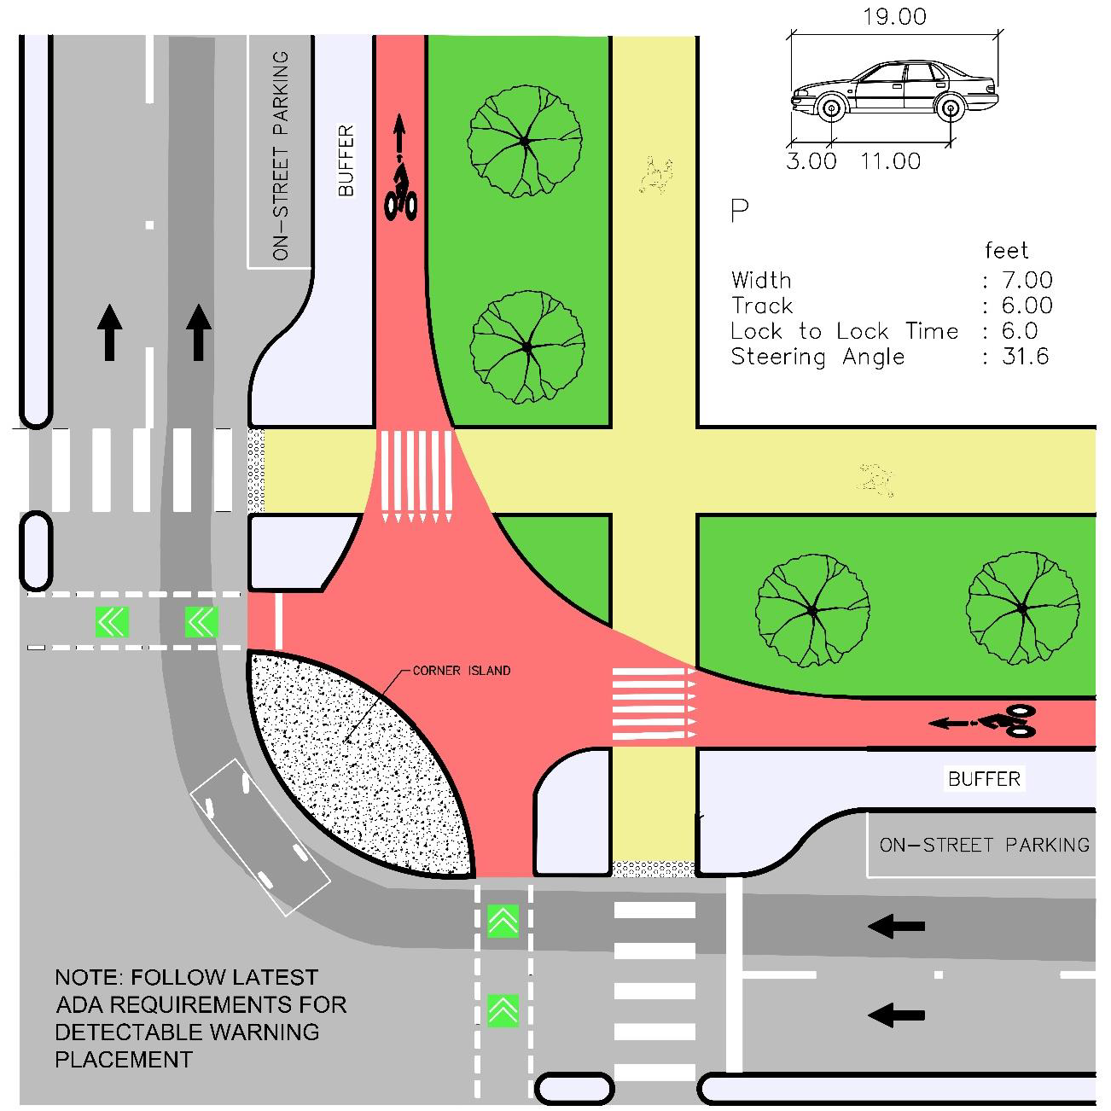
Figure 3-1 — Design Vehicle
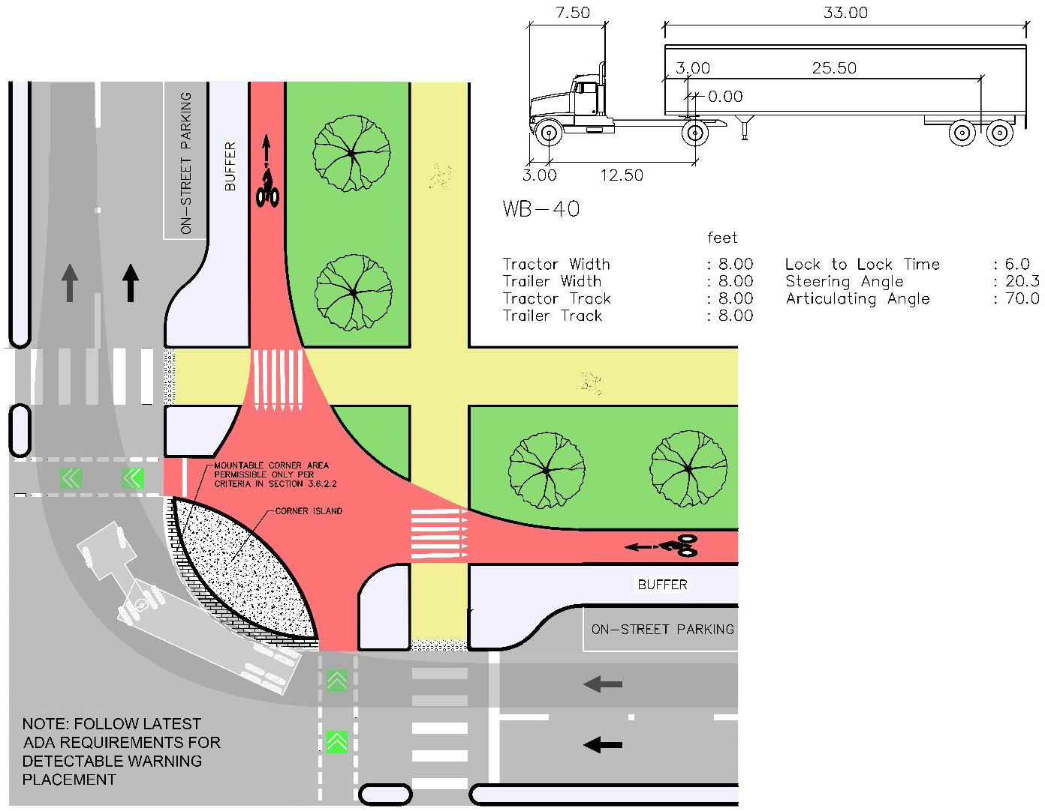
Figure 3-2 — Control Vehicle
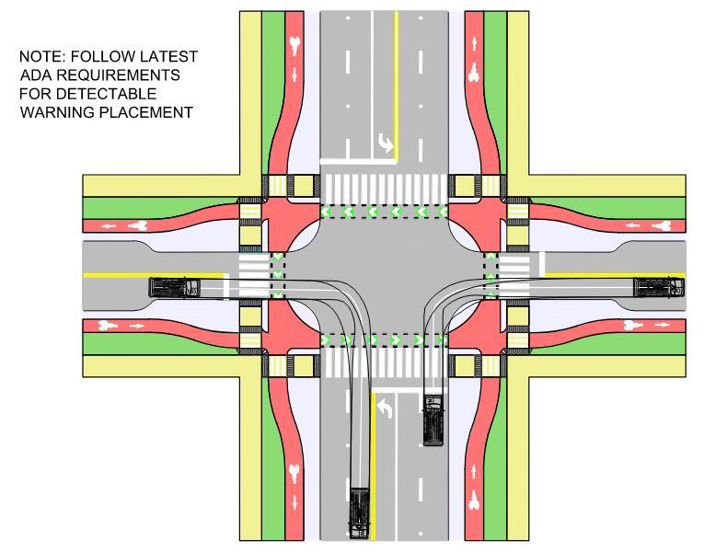
Figure 3-3 — Minor Intersection Swept Path Exhibit Example
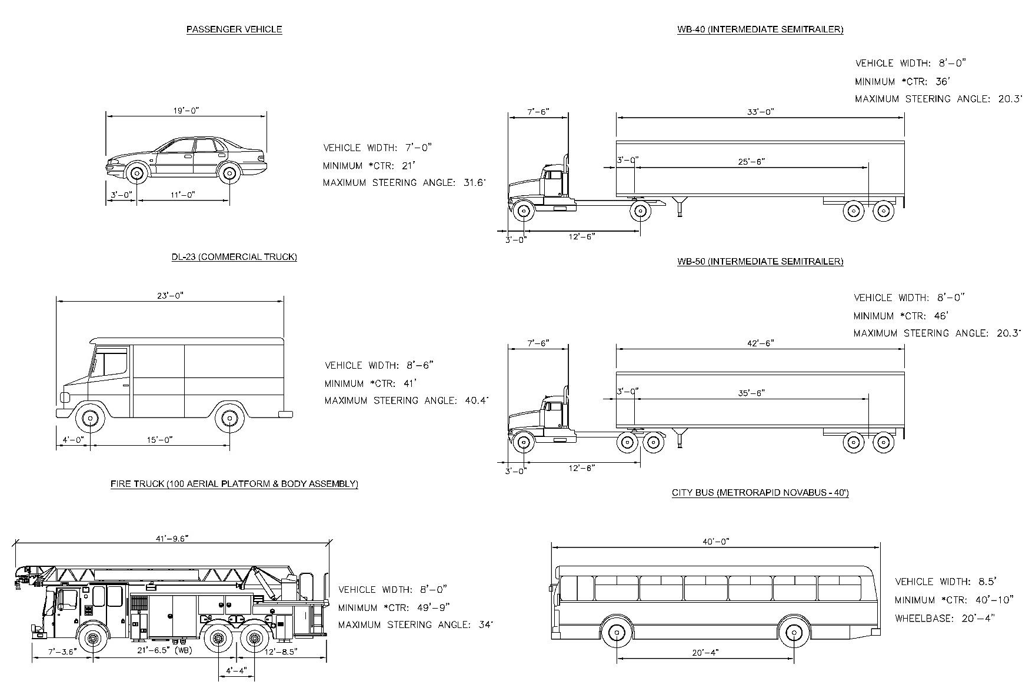
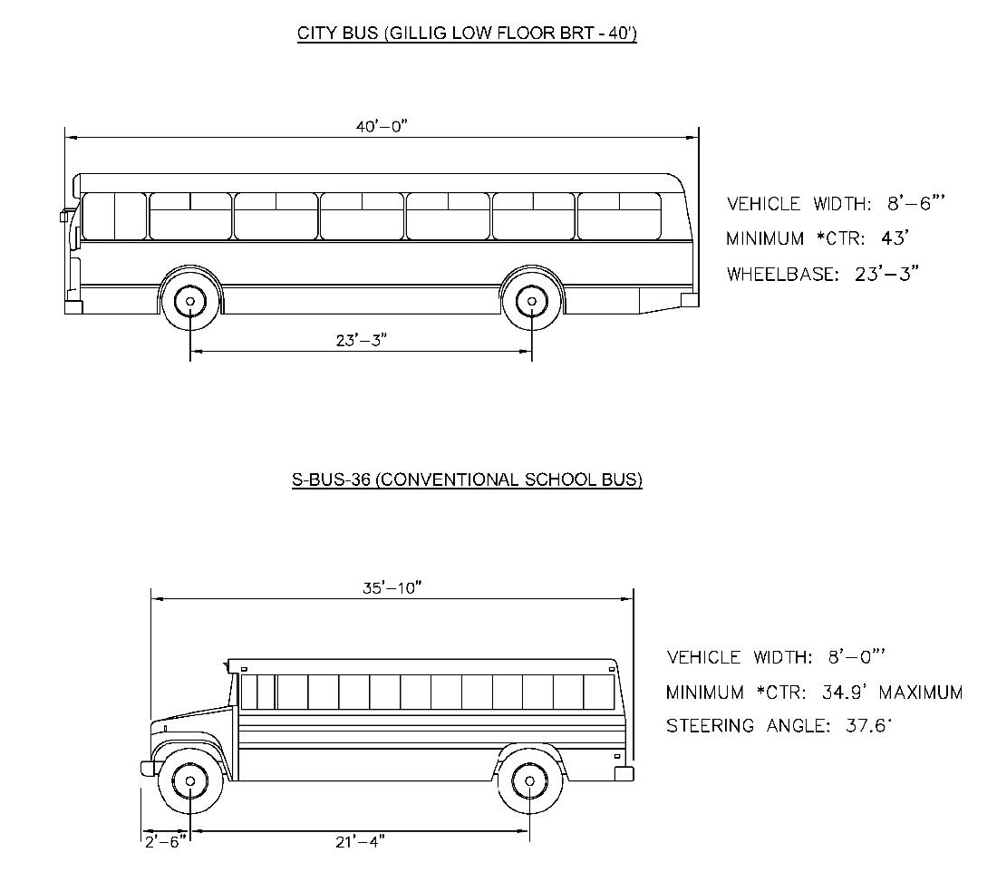
Figure 3-4 — Design & Control Vehicle Dimensions
A. Prior to running turning simulations, the designer shall verify with applicable department what vehicle dimensions are currently accepted.
1. Quint Fire Truck shall be simulations with loads showing the front bucket.
2. Capital Metropolitan Transportation Authority (CapMetro) buses shall be simulated with bike racks down.
B. Departments with vehicular fleets that shall be consulted for current design vehicles include:
1. Austin Fire Department.
2. CapMetro.

3.2.2 TARGET SPEED
The City of Austin uses target speed for design inputs. Target Speed refers to the speed at which vehicles should operate on a street in a specific context, consistent with the level of multimodal activity generated by adjacent land uses, to provide both mobility for motor vehicles and a safe environment for pedestrians and bicyclists.
Table 3-1 below provides guidance for selecting Target Speeds for each Street Level based on conflict density and activity levels. Before initiating design of new streets, capital improvement projects, or retrofits of existing streets, applicants must get pre-approval from the applicable department on selecting the appropriate Target Speed for the project to inform the geometric design features needed to achieve speeds at or below the Target Speed.
Table 3-1 — Street Level Target Speeds
 | Street Context
Street Level | High conflict density  High activity | High conflict density  Low activity | Low conflict density  High activity | Low conflict density  Low activity
Level 0 | 10 mph | 10 mph | 10 mph | 10 mph
Level 1 | 20 mph or lower | 20 mph | 20 mph | 20—25 mph
Level 2 | 20—25 mph | 25 mph | 25 mph | 25—30 mph
Level 3 | 25—30 mph | 30 mph | 30 mph | 30—35 mph
Level 4 | 30—35 mph | 35 mph | 35 mph | 35—40 mph

A. Activity level is determined by the level of potential pedestrian, bicycle, transit and stationary/public use on a street.
High activity streets include streets with any of the following characteristics:
1. Located on an Imagine Austin Activity Corridor or within Centers;
2. Located in the Urban Core (cite reference);
3. Located on the Transit Priority Network;
4. Located with a quarter-mile of a school or park; or
5. Streets with primarily front-facing residential land use.
Low activity streets include all other streets.
B. Conflict density is determined by the degree to which potential conflicts arise on a given street based on how much physical protection between modes the street offers and how closely spaced intersections and other crossing locations are.
High conflict density streets include all streets not defined as a low conflict street. Low conflict density streets only include streets with ALL of the following characteristics:
1. Provides physical separation—including protected bicycle lanes or shared-use paths—for bicycles and micromobility devices;
2. Includes sidewalks or shared-use paths on both sides of the street;
3. No on-street parking or loading zones; and
4. One or fewer intersections, driveways, curb cuts, or other crossing points per ¼ mile.
C. After the target speed of the street has determined and approved, the target speed shall be used to select the design inputs outlined in the following sections.
D. On low conflict density, low activity streets the design of intersection sight distance, vertical curves, and horizontal curves shall be designed at 5 mph above the selected target speed in order to improve safety. By designing these street elements (curves and sight distance) to accommodate higher speeds, visibility should be improved for vehicles maneuvering into potential conflict points.

3.2.3 PAVEMENT MARKINGS & SIGNS
A. All signs and pavements markings shall comply with the latest edition of the TMUTCD.
B. All plans with signs and striping in the City right-of-way must be approved by the applicable department.

3.3.0 DESIGNING FOR SPEED MANAGEMENT
The operating speed of a street is the primary variable impacting the ultimate safety of the street. To achieve Vision Zero, speed must be managed carefully during the design of these streets. As outlined in Section 3.2.2, streets must be designed to the designated target speed so that lower operating speeds can be realized. Level 1 Streets are to operate at a speed of 20 mph and Level 2 Streets at a speed no greater than 30 mph. This is made possible through the application of various speed management techniques. These techniques also greatly improve pedestrian crossing safety and are to be used in conjunction with crossing locations as outlined further in Section 4.
This section outlines standardized speed management techniques for new Level 1 and Level 2 Streets. Retrofits of existing streets with speed management devices shall be determined in consultation with applicable staff from the applicable department using the latest administrative guidelines. Alternative speed management techniques and associated design criteria are shown in Section 3.3.1 through Section 3.3.3. All speed management devices shall be installed per City of Austin Standard Details.
The following Figure 3-5 illustrates a toolbox of speed management design strategies on Level 1 and Level 2 Streets in the City of Austin.
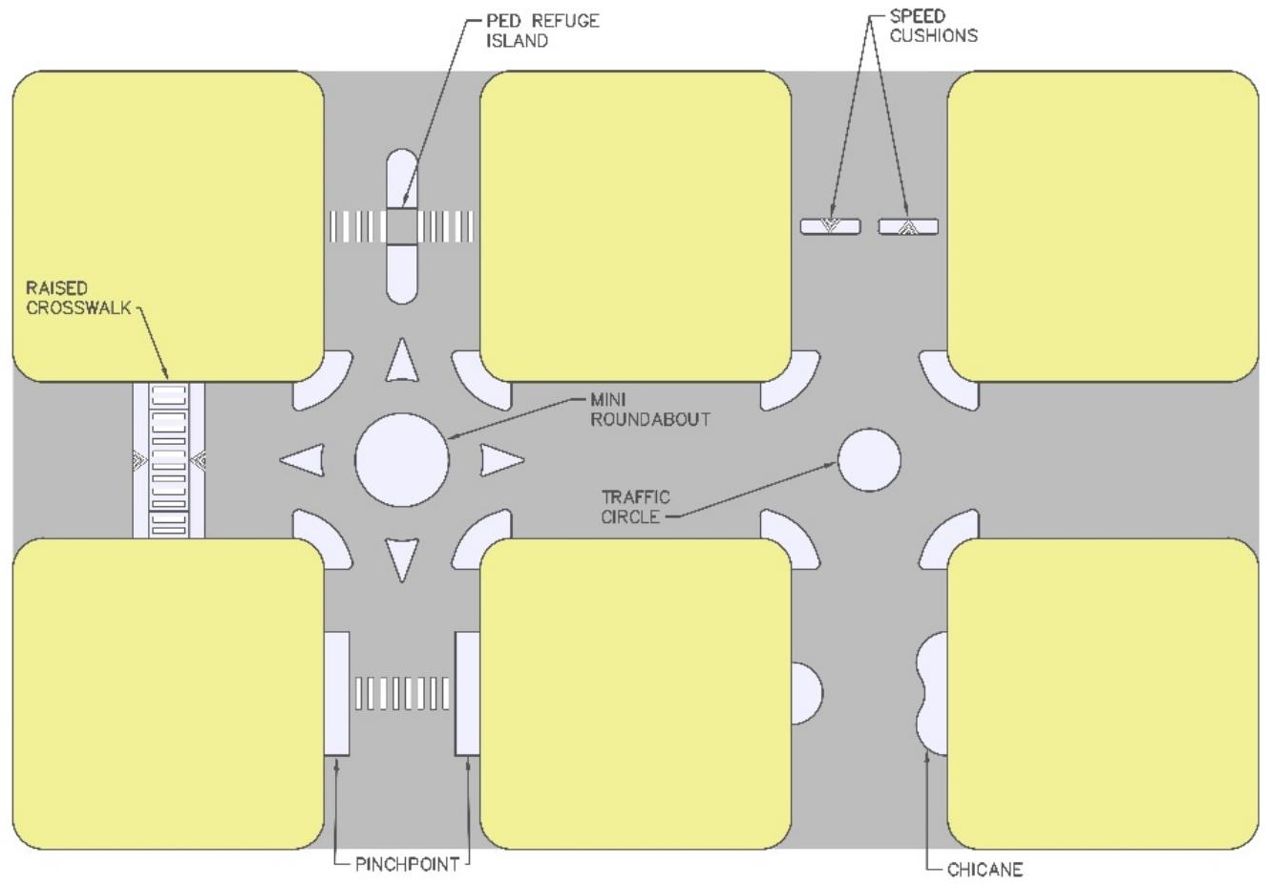
Figure 3-5 — Speed Management Strategies
Table 3-2 — Speed Management Spacing
Street Level | Maximum Spacing Between Treatments (ft.)
Level 1 | 200
Level 2 | 300

A. Speed management technique to be applied shall be approved prior to application by applicable staff of the applicable department if deviating from the following:
1. The standard speed management device on Level 1 Streets shall be a pinchpoint with 12 ft. clear width. These shall be placed with spacing per Table 3-2 from another mid-block device or the nearest intersection with traffic circle, stop control, or raised intersection. Section 2.8.2.2 includes Level 1 Street figures with speed management devices.
2. The standard speed management device on Level 2 Streets shall be a median island or painted median for horizontal deflection. These shall be placed with spacing per Table 3-2 from another mid-block device or at the intersection approach in tandem with a crosswalk. Section 2.8.2.3 includes Level 2 Street figures with speed management devices.
B. Speed management devices should be placed at least 5 ft. from any driveway, entrance, curb cuts on Level 1 and 2 Streets except for median islands.
C. Devices shall maintain a minimum spacing of 2 ft. from manholes or utility poles or points of access.

3.3.1 VERTICAL DEFLECTION
Vertical deflection is an isolated increase in the normal pavement elevation that encourages the driver to slow vehicle speed. Raised crosswalks are the preferred method of vertical deflection on Level 2 Streets. Use of raised crosswalks encourages vehicle speeds to be slower at the point of conflict with pedestrians and bicyclists. When using vertical deflection, positive drainage shall be maintained to avoid ponding of water in the right-of-way.

3.3.1.1 Speed Cushions.
A. Speed cushions shall be designed according to City of Austin Standard Details.

3.3.1.2 Raised Crosswalk.
A. The raised crosswalk shall be from face of curb to face of curb in the traveled way.
B. If bicycles operate in the street where a raised crosswalk is planned, bicycles shall transition across the raised crosswalk location with grades appropriate for their design speed. Maximum slope shall be 10% for ramps across a raised crosswalk when bicycles operate in the street.
C. Raised crosswalks shall be designed so that the design vehicle does not bottom out traversing the raised crosswalk operating at 5 mph.

3.3.1.3 Speed Humps.
A. Speed humps shall be placed from lip of gutter to lip of gutter and designed to cause vertical deflection for vehicles passing through.

3.3.1.4 Raised Intersection.
Raised intersections include an effective speed hump from gutter to gutter at the approach from each direction resulting in a 3—6 in. deflection above street approaches in the intersection area. Raised intersections are applicable on Level 1 Streets.

3.3.2 HORIZONTAL DEFLECTION
Horizontal deflection forces the driver to respond to a changing width or alignment of their anticipated travel path. This response typically results in a lowering of operating speed. Horizontal deflection can be implemented through the construction of a physical barriers or through the application of pavement markings with supplemental vertical devices. Pinch points and bulb-outs at pedestrian and bicycle crossings shall be used wherever possible in order slow vehicle speeds at pedestrian and bicyclist conflict points.
See Section 3.5.2.2 for guidance on tapers when transitional shifts are used with either pavement markings or physical curbs.

3.3.2.1 Median Island.
For design of median islands, reference Section 4. For design of raised central islands at roundabouts, reference Section 3.6.7. Raised central islands and median islands are the preferred speed management techniques to require vehicle to shift horizontally from their travel path and typically results in reduced speeds.

3.3.2.2 Pinchpoint/Bulb-Out.
A Pinchpoint is a location with bulb-outs on both sides of the roadway typically at midblock locations that results in yield flow and significantly reduces speeds.
A. Pinchpoints on Level 1 and 2 Streets shall maintain a minimum width of 12 ft. between face of curb to face of curb and be designed for yield flow operation.

3.3.2.3 Chicane.
A Chicane slows drivers by alternating parking, bulb-outs, or pavement markings along the street. Chicanes deflect the horizontal path of a vehicle and are designed at the target speed or lower to induce reduced speeds.

3.3.2.4 Lane Shift.
A lane shift horizontally may be designed with striping or bulb-outs that deflects a vehicle's path.

3.3.2.5 Diverter.
A diverter is a device that limits through movements for motor vehicles in one or more directions. Some diverters cut across an existing intersection diagonally, while allowing passage for pedestrians and cyclists. Other diverter styles deny entry from a major street or only allow right in, right out movements. Diverters should only be used where the street network pattern is grid-like with a high connectivity index and nearby alternative routes. Traffic diversion can also be used on streets identified as Neighborhood Bikeways in the Austin Bicycle Plan to reduce traffic speeds and volumes to achieve an All Ages and Abilities bicycle facility.

3.3.2.6 Traffic Circle.
A traffic circle is central island, painted or raised with a vertical or mountable curb in the center of the intersection of two streets. Traffic circles paired with a visual obstruction through the intersection, such as a tree, increase the effectiveness of reducing speed. Traffic circles are intended to be yield operated intersections that cause a horizontal deflection in vehicle paths through the intersection.

3.3.2.7 Mini-Roundabout.
For the design of mini-roundabouts, reference Section 3.6.7. Mini-roundabouts are intended to be used as an alternative traffic control measure to a multi-way stop or a two-way stop and should be evaluated through Intersection Control Evaluation in Section 3.7.0. Mini-roundabouts differ from traffic circles in that they require deflection of vehicle paths prior to entry into the intersection, typically through the use of curbed or painted splitter islands.

3.3.3 VISUAL NARROWING TECHNIQUES
Visual narrowing techniques utilize either physical objects, vertical street elements, or pavement markings to communicate to the driver a perceived narrowing of their anticipated path of permissible travel to reduce operating speeds.

3.3.3.1 On-Street Parking.
On-Street Parking, shown in Section 9, can be used as an effective way to narrow a street by creating friction for moving vehicles. On-Street Parking should be designed carefully if a street also has on-street bike facilities because of conflicts from the door zone of vehicles. In addition, on-street parking is particularly effective when coupled with pinchpoints and bulb-outs.

3.3.3.2 Street Trees.
Street Trees, shown in the cross sections in Section 2 and required by the LDC help visually narrow the street. The visual narrowing effect is more pronounced the closer the trees are to the edge of travel way for vehicles. For specific criteria on street trees, see the Environmental Criteria Manual.

3.4.0 LEVEL 0 & 1 STREET DESIGN
This section applies to all new streets designed within sites that where the primary function of the street is access to lots within the property. All applicable criteria and references to other sections contained in this manual is listed below.

3.4.1 LEVEL 0 STREETS
Table 3-3 specifies general design criteria for Level 0 Streets.
Table 3-3 — Level 0 Design Criteria
Target Speed | Typical Section | Min Grade - G (%) | Max Grade - G (%) | Design min K Value Sag Vertical Curve | Design min K Value Crest Vertical Curve
10 | Refer to Section 2.8.2.1 | 0.6 | 8 | 26 | 12

A. Level 0 Streets shall not intersect with Level 2, 3, or 4 Streets.
B. Level 0 Streets shall not align with existing or future streets, except driveways on the opposite side of the street.
C. Level 0 Streets shall be perpendicular.
D. Internal Level 0 Street intersections shall consist of no more than three Level 0 residential street approaches.
E. The radius of Level 0 Streets pavement at street intersections shall be less than 15 ft. At the intersection of two Level 0 Streets, the radius of the alley right-of-way is dependent upon the Level 0 Streets right-of-way intersection angle.
F. If a Level 0 Street will serve Fire Department vehicles, consultation with the Fire Department must occur prior to approval for appropriate design.
G. Parking is not allowed on Level 0 Streets.

3.4.1.1 Turnarounds.
A. If a Level 0 Street terminates in a dead end and the City Transportation Engineer or applicable Director determines that the Level 0 Street will not connect in the future, a turnaround must be provided. Details for the design of a turnaround are shown in Figure 3-6.
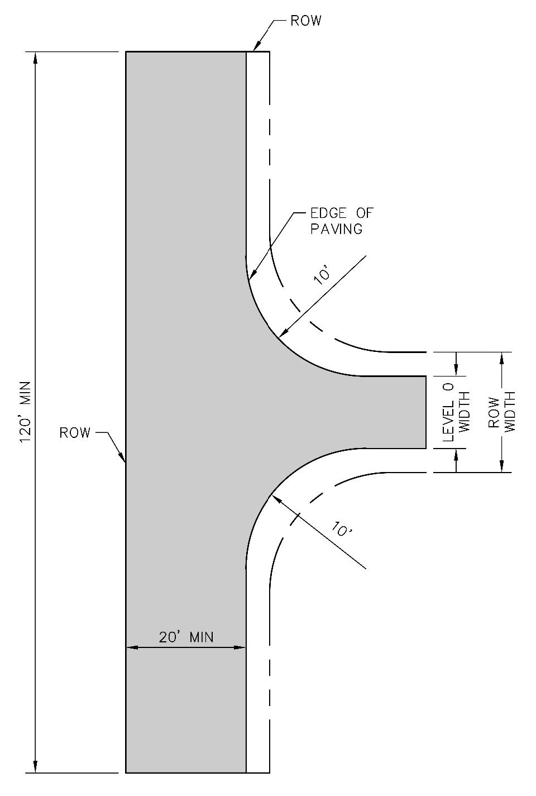
Figure 3-6 — Level 0 Turnarounds

3.4.2 LEVEL 1 STREETS
This section covers design criteria for Level 1 Streets. Level 1 Streets provide connectivity to higher Level Streets. The design criteria shown apply to private streets in Section 3.4.2.3. Table 3-4 specifies general design criteria for Level 1 Streets.
Table 3-4 — Level 1 Design Criteria
Target Speed | Typical Section | Horizontal Radius (Measured at Inside Travel Way) (ft.) | Min Grade - G (%) | Max Grade - G (%) | Design min K Value Sag Vertical Curve | Design min K Value Crest Vertical Curve | Maximum Tangent Length along Street Centerline
20 | Refer to Section 2.8.2.2 | 200 | 0.6 | 8 | 26 | 12 | 1,000
25 |  | 350 | 0.6 | 8 | 37 | 19 | 1,500

3.4.2.1 Intersection Design.
This section governs design of intersections with Level 1 Streets. If intersection is with only Level 2 Streets or higher refer to Section 3.6.0. Crossings for street users outside the Motor Vehicle and Transit Zone must be highly visible to vehicular traffic and must be considered at every intersection. Refer to Section 4 and Section 5 for further guidance on pedestrian and bicycle crossings. Table 3-5 shows the allowable intersection controls for each intersection type with Level 1 Streets. Intersection controls shall be determined through an engineering evaluation considering anticipated intersection entering volumes and be approved by applicable staff.
Table 3-5 — Level 1 Intersection Controls
Level 1 | Level 2 | Level 3 or higher
Traffic circle, Multi-way^{B} or two way stop control | Mini-roundabout^{A} , multi-way stop control^{B} , or Minor Street Crossing | Minor Street Crossing Traffic Signal^{C}
^{A} Refer to Section 3.6.7 for mini-roundabout design criteria.
^{B} Multi-Way stop warrants per the TMUTCD are recommended for existing intersections. New intersections may install multi-way stop control based on planning level analysis.
^{C} Signal warrants must be conducted and recommendation approved by the applicable department.

Figure 3-7 illustrates configurations of minor street crossings for both a separated pedestrian and bike facility and a shared use path crossing. Design criteria for these minor street crossings for Level 1 Streets are included in this section. Figure 3-8 illustrates a turn restriction raised island device. These devices, if required to restrict turning movements, shall provide design provisions for bicycle and pedestrian access cut throughs to limit access restrictions to motor vehicles. For a grade profile of a minor street crossing, refer to Section 5.2.1.
Figure 3-9 illustrates a raised intersection at a Level 1 intersecting a Level 1 Street intersection.
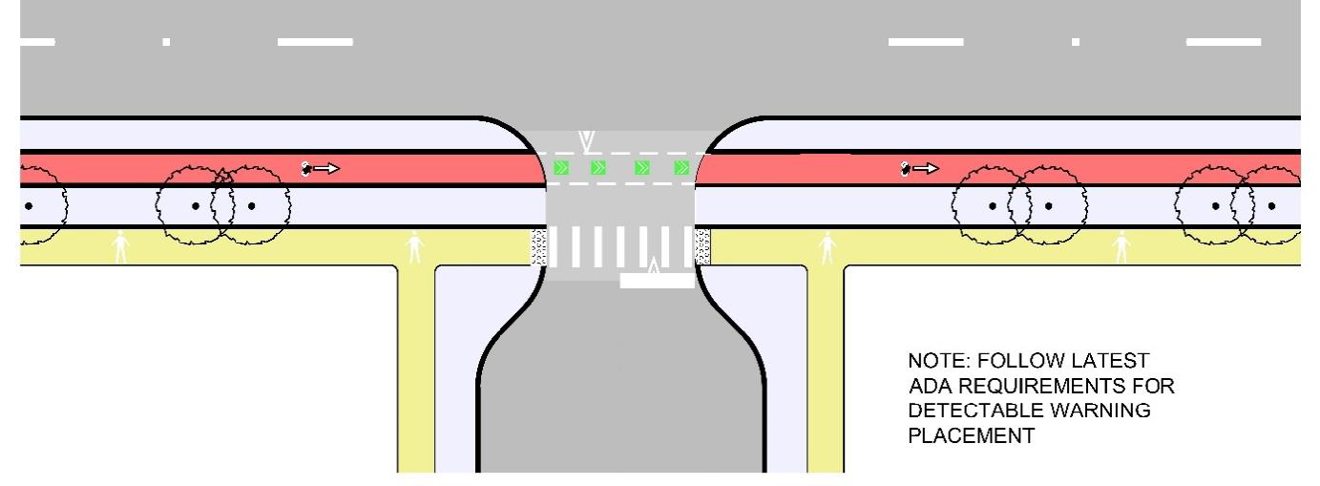
Figure 3-7 — Separated Bike and Pedestrian Minor Street Crossing
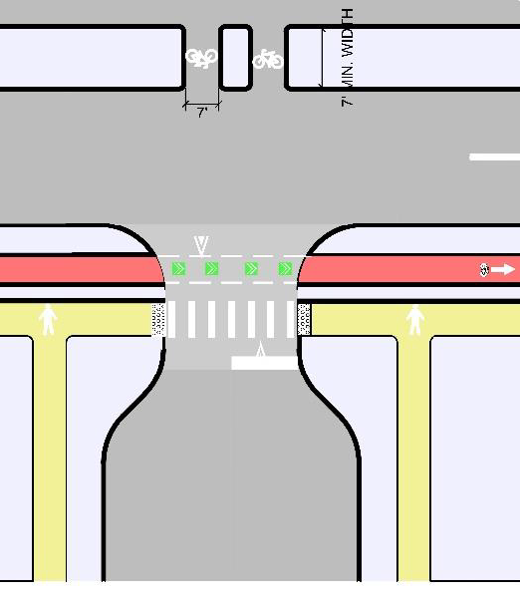
Figure 3-8 — Turn Restricted Movement with Bicycle Cut-Through Example
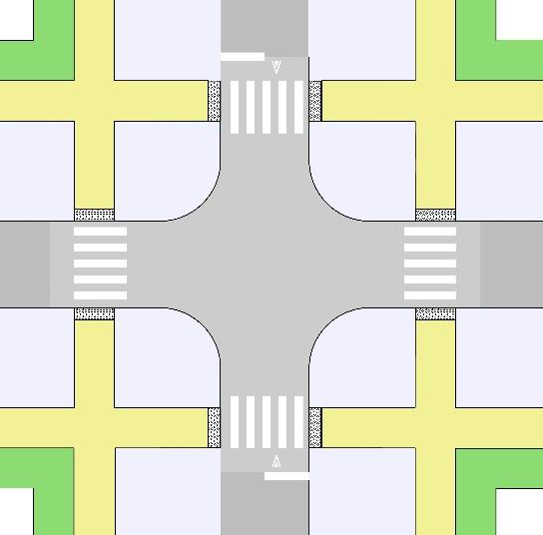
Figure 3-9 — Raised Intersection Typical Layout
Criteria Applicable at Level 1 to Level 1 Intersections
A. Width between bulb-outs shall be 20 ft. minimum.
Criteria Applicable at Minor Street Crossings (Level 1 to Level 2 or Higher Intersections)
B. Width between bulb-outs shall be 24 ft.
C. Raised crossings of minor streets are required for all Level 1 intersections with Level 2 or higher streets. They enhance safety by reducing motor vehicle speeds and enhancing visibility for people walking and bicycling.
D. Raised crossings shall be made of concrete for durability and maintenance. Reference City of Austin Standard Details for design requirements of raised crossings.
E. Material and color of bicycle and pedestrian facilities along the major street shall continue through the minor street crossing.
F. As necessary, use either inlets to catch water in advance of the raised crossing or use pass through rain gardens with bridges for bikeway and sidewalk.
G. The maximum slope of raised crossing treatment is +/- 6% or +/- 4% from running street grade.
H. Elevation of raised crossing shall be between 3 in. to 6 in. with 4 in. preferred height.
I. Yield lines shall be used in conjunction with the raised crossing.

3.4.2.1.1 Intersection Sight Distance.
Intersection sight distance (ISD) triangles are to be determined for all turning movements that are not controlled. ISD is the length of the sight triangle leg measured along the major street which a minor street is intersecting. Once the sight triangle has been determined for the turning movement, the triangle shall be clear of obstructions that restrict the vision of street users. Examples of potential visual obstructions include, but are not limited to the following: fences, walls, monument signs, trees, bushes, berms, or other manmade structures that impede view. Measurement of sight distance shall be from the location of a stopped vehicle or 6.5 ft. from the edge of the outside lane edge, measured 8 ft. from the front of the vehicle. Tables 3-6 through 3-8 identify minimum lengths of ISD. See Section 11.2.1 for additional information about landscaping in sight triangles.
Table 3-6 — Minimum Intersection Sight Distance Length by Target Speed Case B1
(Left turn from stop)
Target Speed | Minimum Intersection Sight Distance (ISD)
20 mph | 225 ft.
25 mph | 280 ft.
30 mph | 335 ft.
35 mph | 390 ft.
40 mph | 445 ft.
45 mph | 500 ft.

Table 3-7 — Minimum Intersection Sight Distance Length by Target Speed Case B2
(Right turn from stop)
Target Speed | Minimum Intersection Sight Distance (ISD)
20 mph | 195 ft.
25 mph | 240 ft.
30 mph | 290 ft.
35 mph | 335 ft.
40 mph | 385 ft.
45 mph | 430 ft.

Table 3-8 — Minimum Intersection Sight Distance Length by Target Speed Case B3
(Crossing Maneuver)
Target Speed | Minimum Intersection Sight Distance (ISD)
20 mph | 195 ft.
25 mph | 240 ft.
30 mph | 290 ft.
35 mph | 335 ft.
40 mph | 385 ft.
45 mph | 430 ft.

A. Minimum ISD in Tables 3-6 through 3-8 are determined using the default variables outlined in the AASHTO Green Book. Refer to the latest edition of the AASHTO Green Book if the default variables vary for turning movement being designed for.
B. Based on the type of movements and intersection controls, the design shall provide the required ISD for given scenario described by the AASHTO Green Book.
C. An analysis of the vertical profile within the area defined by the ISD horizontal profile value must also be completed to ensure oncoming traffic can be continuously seen and not obstructed by street grades or objects.
D. An intersecting street or driveway may not be appropriate along a vertical curve when required sight distance from side street or driveway is not attainable. If it is essential that a side street or driveway intersect the major street along a vertical curve, then it may be necessary to reduce the vertical curve so that necessary sight distance is available.
E. For streets with multiple through travel lanes in either direction and a speed of greater than 35 mph posted, left turns shall not be allowed from intersecting streets without a traffic signal or other operation to protect left turns from the intersecting street without City Transportation Engineer or applicable Director approval.

3.4.2.2 Culs-de-sac.
The LDC defines when single access streets or cul-de-sacs will be permitted within the City and are prohibited without City Transportation Engineer or applicable Director approval. Cul-de-sacs shall be used sparingly as they violate the Comprehensive Plan goal for a "compact and connected" City. Design of these facilities is governed herein, when applicable. Single access streets have one point of access. Cul-de-sac streets are open at one end, with the closed end constructed to facilitate a turnaround for the appropriate design vehicle for the street. Figure 3-10 shows an illustration of single outlet streets and cul-de-sacs. Required radii and design vehicles based on Street Level are shown in Table 3-9.
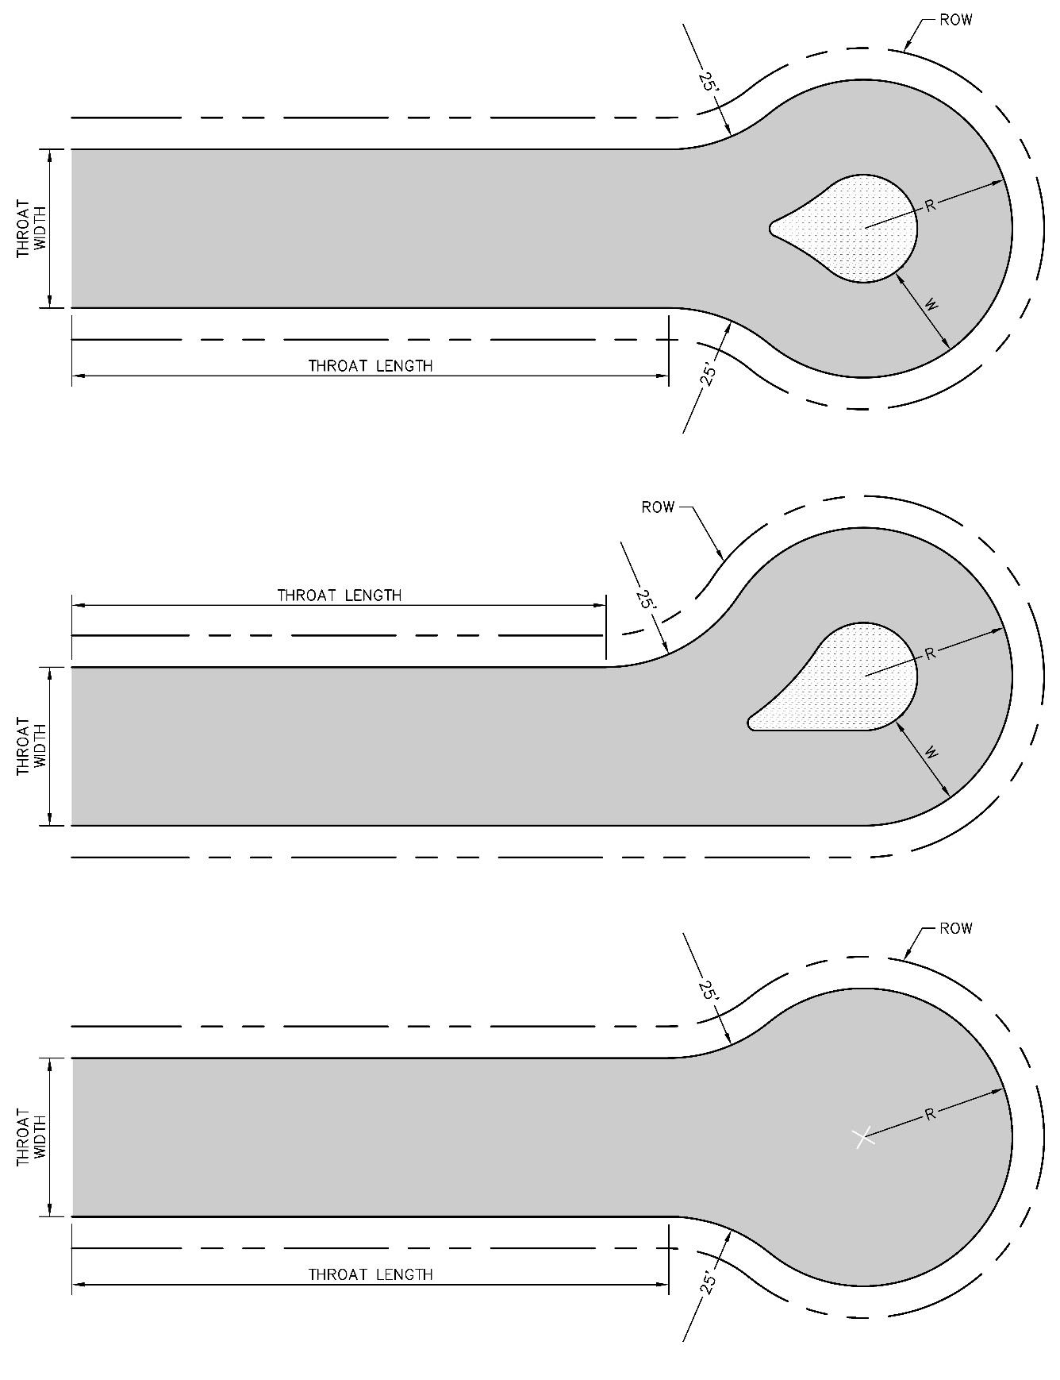
Figure 3-10 — Cul-De-Sac Geometry
Table 3-9 — Cul-De-Sac Design Criteria
Cul-De-Sac Throat Geometry
 | Level 1 |  | Level 2
Throat Width (ft.) | 30 |  | 36
Throat Length (ft.) | 150 (min) | 300 (max) | 200 (min) | 300 (max)
Cul-De-Sac Center Radius Geometry
Design Vehicle | Center Radius (R) (ft.) |  | Paving Width (W) (ft.)
Fire Truck (COA) | 48 |  | 25
WB-40 (Intermediate Semitrailer) | 42 |  | 25
WB-50 | 47 |  | 30

A. Single outlet streets that are not Level 0 Streets and have a face-of-curb to face-of-curb width of less than 40 ft. or are undivided, are required to terminate in a cul-de-sac.
B. Level 1 and Level 2 Streets shall be designed with one of the configurations shown in Figure 3-10.
C. Level 3 and higher streets shall not terminate as a single outlet street unless it is a divided street with adequate space for a turnaround for the appropriate design vehicle, provided at a dead end signed for future connection.
D. If the design vehicle differs from the vehicles listed in Table 3-9, swept path analysis shall be shown on plans for the design vehicle using computer aided design software. The proposed paving geometry shall allow the vehicle to maneuver within the paving limits.

3.4.2.3 Private Streets.
A. A private street is a vehicular roadway under private ownership and maintenance which is not intended for use by the general public and may have its access controlled or restricted.
B. Private streets are subject to City regulations in order to ensure:
1. Safe movement of all street users from a private street to a public street system.
2. Adequate access to all buildings and lots by emergency and service vehicles.
3. Adequate construction standards in the event that private ownership becomes dedicated as public streets.
4. Adequate drainage and utilities.
C. Traffic control devices on private streets must conform with the Texas Manual on Uniform Traffic Control Devices (TMUTCD) latest edition per the Texas Transportation Code, Section 544.002.
D. Right-of-way for a private street is not dedicated to the public; however, it may be designated as a "private street, drainage, and public utility easement."
E. To discourage vehicular through traffic, private streets shall not form a direct link between two public streets that serve public through traffic, however direct links can be provided for sidewalks and shared use paths.
F. Connection to two public streets to accommodate internal circulation is permitted.
G. Should a private street with gated access become public, all security gates shall be removed, and the street must be brought to current acceptance criteria for a Level 1 Street.
H. Within the City's zoning jurisdiction, permits for driveway and sidewalk construction along private streets will be required as for public streets.

3.4.2.3.1 Conversion of Existing Private Streets to Public Streets.
In certain cases, the City may allow existing private streets to be converted to public streets. In order to be accepted by the City as public streets, the following conditions must be met:
1. The streets must conform to the design criteria in Section 3.4.2, as well as the pavement design standards in Section 14 and Appendix B. The owners of the private street must provide documentation verifying the cross-section construction of the private street.
2. There must be no outstanding unpaid taxes owed on the streets.
3. Existing building setbacks, lot widths, lot sizes, and yard sizes must conform to the requirements of the zoning district in which they are located, based upon the right-of-way lines established at an appropriate distance from the edge of the pavement.
4. A street deed must be prepared and processed through normal procedures to dedicate the right-of-way to the public, with the concurrence of all abutting property owners. The owners of the private street are responsible for surveying and conveyance of the right-of-way to the City.
5. Any covenants or other legal documents which created the private streets must be amended or terminated.
6. Any existing security gates, overhead rock entrance ways, speed bumps, special pavement treatments, and similar facilities which do not meet City design standards must be removed and the pavement repaired in an acceptable manner at the owner's expense, as determined by the Director of the Public Works Department.
7. Sidewalk construction must conform to Section 4 and be brought into PROWAG or ADA compliance.
8. Private improvements left within the proposed right-of-way may require license agreements.
9. Street lighting, signals, and other street-related infrastructure must be acceptable to the applicable department.
10. The street must be inspected by the Public Works Department. All needed repairs or maintenance strategies identified during the inspection must be made and paid for by the owners of the private street prior to acceptance by the City. Repairs of maintenance strategies must conform to the same requirements and specifications as required for public streets. The City will have no obligation to repair, maintain, or reconstruct newly accepted private streets for a period of two years, unless required by emergency or safety reasons.
11. Designated off-street parking and garbage container areas will not become the responsibility of the City.
12. The City shall reserve the right to deny acceptance of the private street if current City street maintenance budgets are 90% or less of the current maintenance needs.

3.5.0 HORIZONTAL AND VERTICAL GEOMETRIES
The following design criteria are intended to guide the selection of design inputs governing the horizontal, vertical, and cross-sectional dimensions along the street alignment. These inputs should be determined at the earliest stage of the design process. As these design inputs influence the ultimate performance of the street, careful attention must be taken to choose values that will result in a performance that will last throughout the design life of the street. This will reduce the need for reconstruction and speed management treatments after completion.

3.5.1 RELATIONSHIP TO TARGET SPEED
Once the target speed has been chosen for the street, horizontal and vertical design inputs can be chosen. All design variables in the following tables are to be chosen based on selected target speed. As explained in Section 3.2.2., target speed aims to keep operating speeds at the posted speed of the roadway. For further explanation of the design variables that follow, refer to the latest edition of the design manuals listed in Section 1.3.0.

3.5.2 HORIZONTAL GEOMETRY
The material covered in this Section governs the design criteria for horizontal geometry of the street. Horizontal geometry of the street dictates the left to right movement felt by the driver when traveling along the street alignment. A horizontal curve or transition must be introduced when tangent sections of the street are shifted laterally as a result of adjacent property lines, topographic features, narrowing or widening of the street, aligning with an existing street section, or as a form of speed management. Geometric changes can be influenced by both physical and visual cues along the street. Physical cues are encouraged in order to better influence driver behavior.

3.5.2.1 Horizontal Curves.
Figure 3-11 illustrates the measurement of a horizontal curve radius. Table 3-10 establishes the minimum horizontal curve radius based on target speed.
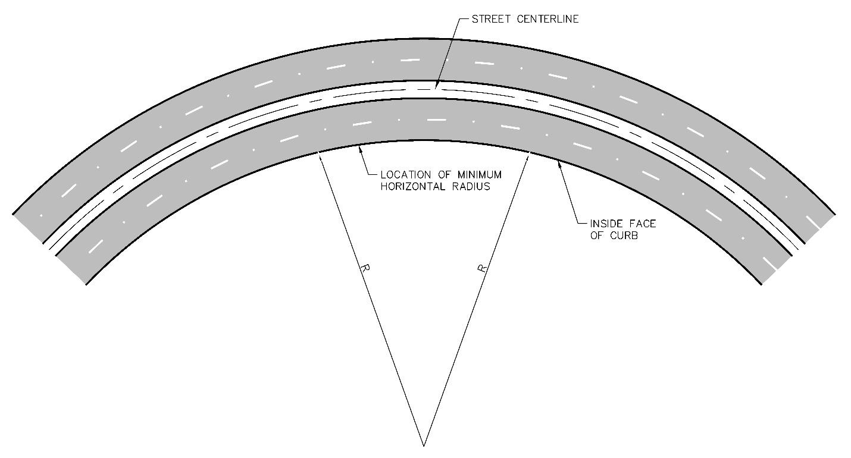
Figure 3-11 — Minimum Horizontal Radius Dimensioning
Table 3-10 — Minimum Horizontal Radius
Target Speed (mph) | Minimum Horizontal Radius (ft.)
20 | 200
25 | 350
30 | 525
35 | 775
40 | 1,050
45 | 1,400

A. The rounded horizontal radius was calculated using a superelevation rate, e, of -0.02. This equates to a 2% typical normal crown used on Level 1—4 Streets.
B. Horizontal radii listed in Table 3-10 are measured along the inside of the inside travel way.
C. Horizontal radii shall not be higher or lower than the values listed in Table 3-10 unless approved by staff member of applicable department.

3.5.2.2 Tapers.
The following section governs the design of tapers along a street. Tapers are typically used when designing transitions to add or remove through lanes in the direction of travel. Tapers may also be used for lateral shifts in roadway geometry for speed management purposes. Table 3-11 and Figure 3-12 show the design criteria for taper length based on target speed and modifications to taper length based on application of a taper in design for various scenarios.
Table 3-11 — Minimum Taper Lengths
Target Speed | Minimum Taper Length Equation
20 | L = W(S⁁2) / 60
25 | L = W(S⁁2) / 60
30 | L = W(S⁁2) / 60
35 | L = W(S⁁2) / 60
40 | L = W(S⁁2) / 60

a) L = Taper length (ft.).
b) S = Target speed (mph).
c) W = Taper shift width (ft.).
d) Minimum desirable taper lengths vary depending on the taper shift width (W).
e) For turn bay tapers refer to the TxDOT Roadway Design Manual.
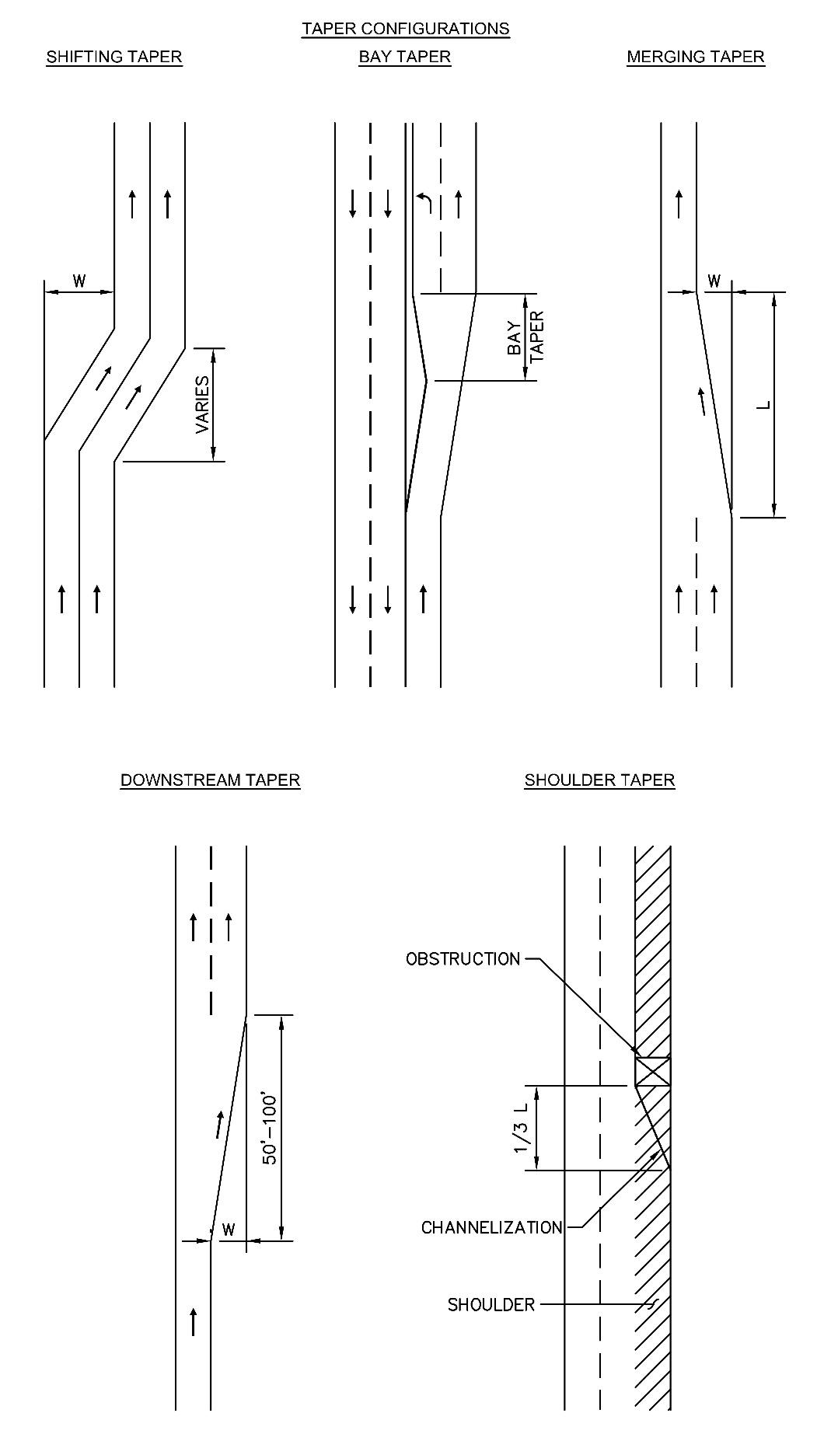
Figure 3-12 — Taper Types
A. A Merging Taper (L) is defined as a pavement transition that results in a reduction of travel lanes at the prevailing speed, requiring vehicles to merge into adjacent traffic lanes.
B. A Shifting Taper is defined as a pavement transition where all approaching traffic lanes shifts laterally but does not require merging with adjacent traffic streams. Minimum taper lengths in Table 3-11 may be used and divided in half (L/2) for speed management design in Section 3.3.2.
C. A Downstream Taper (50 ft. to 100 ft.) is defined as a pavement transition that results in the widening of pavement or travel lanes.
D. Pavement transition design for permanent conditions shall be done in accordance with procedures outlined on the AASHTO Green Book.
E. For a temporary condition, pavement transition shall be designed in accordance with the Texas Manual on Uniform Traffic Control Devices (TMUTCD) or with guidelines set forth in Section 8 of this manual. Section 8 of the TCM shall control if guidelines are in conflict.
F. In situations where more than one merging or shifting tapers are used in sequence between Level 3 Streets, the design must be reviewed by the City Transportation Engineer or applicable Director.
G. If a taper is designed as back to back curves rather than a single tangent, curve radii shall be the same and meet the minimum requirement outlined in Section 3.5.2.1.

3.5.3 VERTICAL GEOMETRY
The content covered in this section governs design criteria for the vertical geometry of streets. The vertical geometry of the street pertains to the series of longitudinal grades along the street alignment connected by parabolic vertical curves to which the straight lines are tangent. Under all conditions, this line should be smooth flowing. Short, choppy grades are unsightly and disrupt operating conditions. The design of the vertical geometry of the street must align with the surrounding terrain to ensure existing drainage patterns are preserved while also balancing the safety and operations of adjacent properties and other users of the right-of-way.
Minimum grades are governed by ensuring drainage flows can be maintained and pass unrestricted to the outfall. Maximum grades are governed by the traversing abilities of control vehicles traversing the street. Grade transitions use vertical curves as shown in Figure 3-13, preferred grade strategies are shown in Figure 3-14, and preferred vertical curve design strategies are shown in Figure 3-15.
Design for crest vertical curves is governed by stopping sight distance and design for sag vertical curves is governed by headlight beam distance. Stopping sight distance measurement is shown in Figure 3-16.
Table 3-12 and accompanying Equations 3-1 through 3-5 shall be used for the design of vertical curves and grades. Equations are taken directly from AASHTO design criteria. If equations in this manual are in conflict, use the latest edition of the AASHTO Green Book for vertical curves and grades. These formulas may be updated by the City Traffic Engineer or applicable Director.
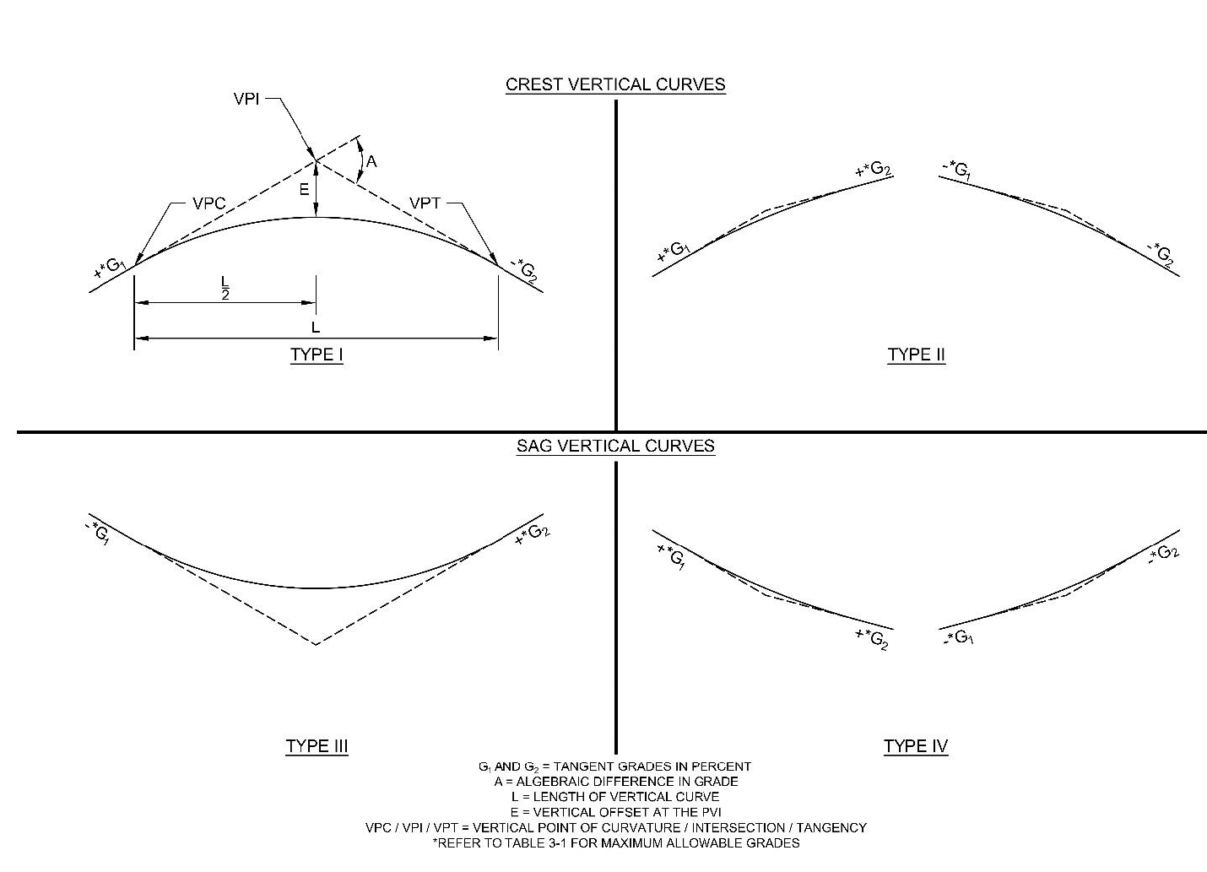
Figure 3-13 — Vertical Curve Types
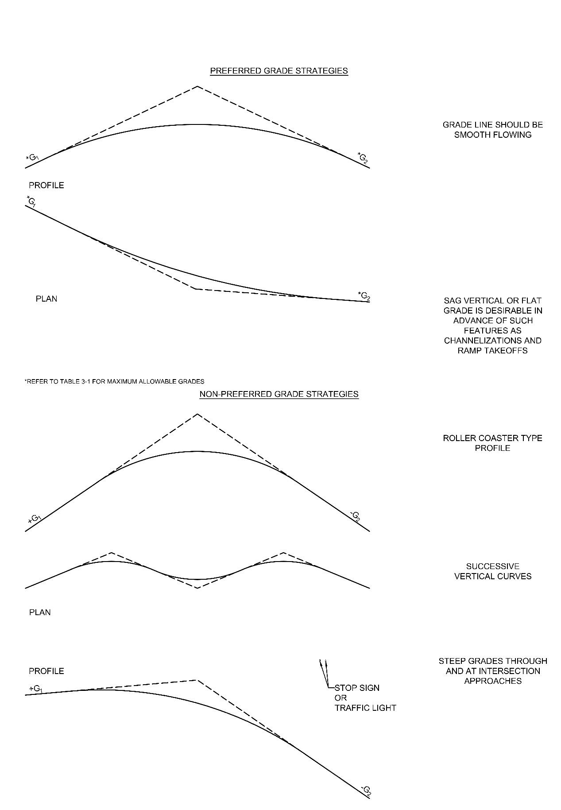
Figure 3-14 — Preferred Grade Strategies
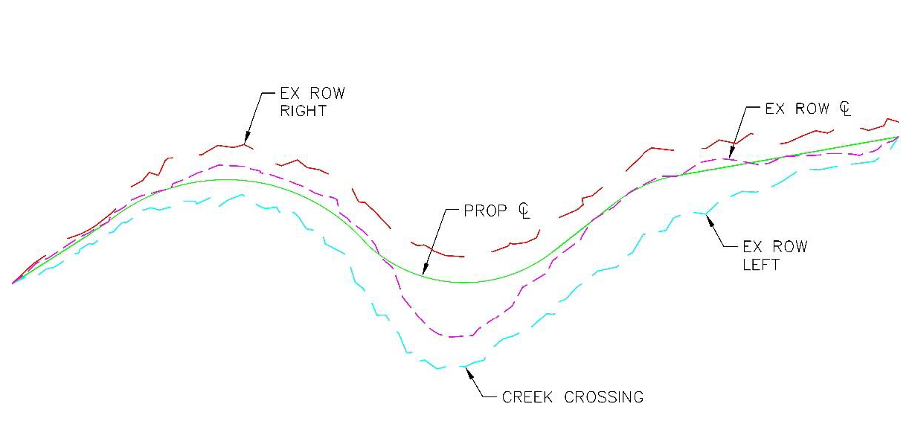
Figure 3-15 — Preferred Vertical Curve Design Strategies
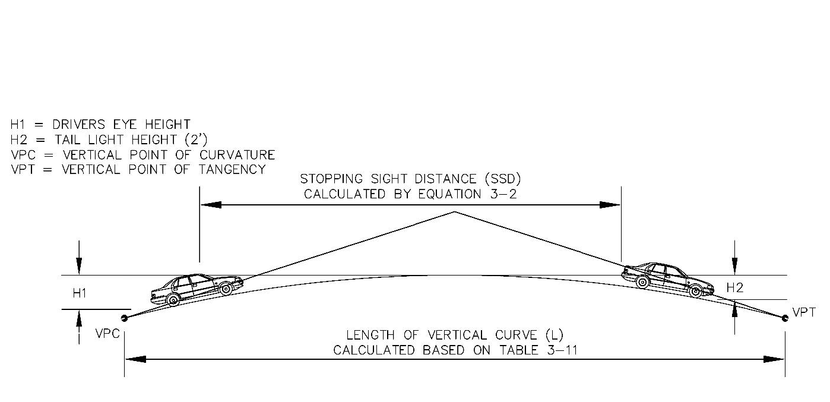
Figure 3-16 — Vertical Curve Stopping Sight Distance
Table 3-12 — Vertical Geometry Design Criteria
Target Speed (mph) | Min Grade - G (%) | Max Grade - G (%) | Stopping Sight Distance (ft.) | Design min K Value Sag Vertical Curve | Design min K Value Crest Vertical Curve
20 | 0.6 | 8 | 155 | 26 | 12
25 | 0.6 | 8 | 200 | 37 | 19
30 | 0.6 | 8 | 250 | 49 | 29
35 | 0.6 | 6 | 305 | 64 | 44
40 | 0.6 | 4 | 360 | 79 | 61
45 | 0.6 | 4 | 425 | 96 | 84

Braking Distance in feet is determined from the formula:
Equation 3-1
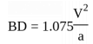
BD = Braking Distance, ft.
V = Target Speed, mph
a = deceleration rate, ft./s² , per AASHTO Green Book
Stopping Sight Distance (SSD) in feet is determined from the following formula:
Equation 3-2 SSD = 1.47Vt + BD
SSD = Stopping Sight Distance, ft.
V = Target Speed, mph.
t = time gap for minor road vehicle to enter the major street(s), per AASHTO Green Book.
BD = Braking Distance, ft.
Rate of vertical curve grade change is determined as "K" in the following formula:
Equation 3-3 K =
Minimum length of crest vertical curve length (stopping sight distance) is determined from the following formula:
Equation 3-4
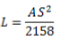
Minimum length of sag vertical curve (headlight sight distance or stopping sight distance) is determined from the following formula:
Equation 3-5
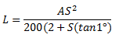
L = Minimum length of vertical curve (ft.).
A = Algebraic difference in grades (G - G).
K = Rate of grade change along vertical curve (ft./1%).
S = Stopping sight distance (ft.).
A. Climbing lanes shall be provided when grades exceed those in Table 3-12 due to existing topography on all Level 3 and Level 4 Streets, and on non-curbed and guttered Level 2 Streets in the area defined in Figure 2-2 in Section 2.
B. For Level 5 facilities refer to the TxDOT Roadway Design Manual.
C. A minimum grade of 0.5% shall be used where existing terrain allows. When 0.5% is determined to not be feasible by the design engineer, a minimum grade of 0.6% shall be used and approved by applicable staff.
D. A maximum grade break of 1.5% may be used without a vertical curve for Level 0—Level 2 Streets. For Level 3—Level 5 Streets, the maximum grade break shall be 1.0% without the use of a vertical curve.
E. Within the intersection physical area (Section 3.6.4.1), the street grade shall be above the minimum allowable grade and less than 2% to ensure pedestrian crossings meet ADA standards.
F. Where streets intersect, the grade of the smaller Level Street shall align with the cross slope of the larger Level Street, not to exceed 2%. Reducing the cross slope to 1% is encouraged to reduce vehicle vaulting across the intersection.
G. When a street is designated as a truck route, grades shall not exceed 6%. If grades must exceed 6%, a climbing lane must be provided.
H. In cases where horizontal curvature on a downgrade causes sight distance obstruction, a higher deceleration rate shall be used to account for difficulty of larger vehicles to stop adequately.

3.5.4 CROSS SECTIONAL ELEMENTS
This section governs the cross-sectional elements within the Motor Vehicle and Transit Zone and the considerations that must be made during design. Cross sectional features relate to the widths and cross slopes experienced by driver as they navigate from side to side along street. Lane widths are the primary variable that influence driver comfort, while medians provide a barrier that separates opposing direction of traffic and provides for access management. Cross slope runs transverse to the street alignment and facilitates passage of surface drainage to curbside inlets or roadside ditches. Criteria contained within this section supplement the required widths of cross-sectional elements presented in Section 2.

3.5.4.1 Lane Widths.
Adjacent travel lanes going in the same direction are to be separated by pavement markings with the possible addition of retroreflective raised pavement markers. Lanes are the spaces within the street cross section that are to be used for safe passage of vehicular traffic. Chosen lane widths directly impact the normal operating speed of a street. Lane widths shall not be made wider or narrower than as specified in Section 2. The width of travel lanes is determined by the clear width provided. Figure 3-17 illustrates lane width measurements.
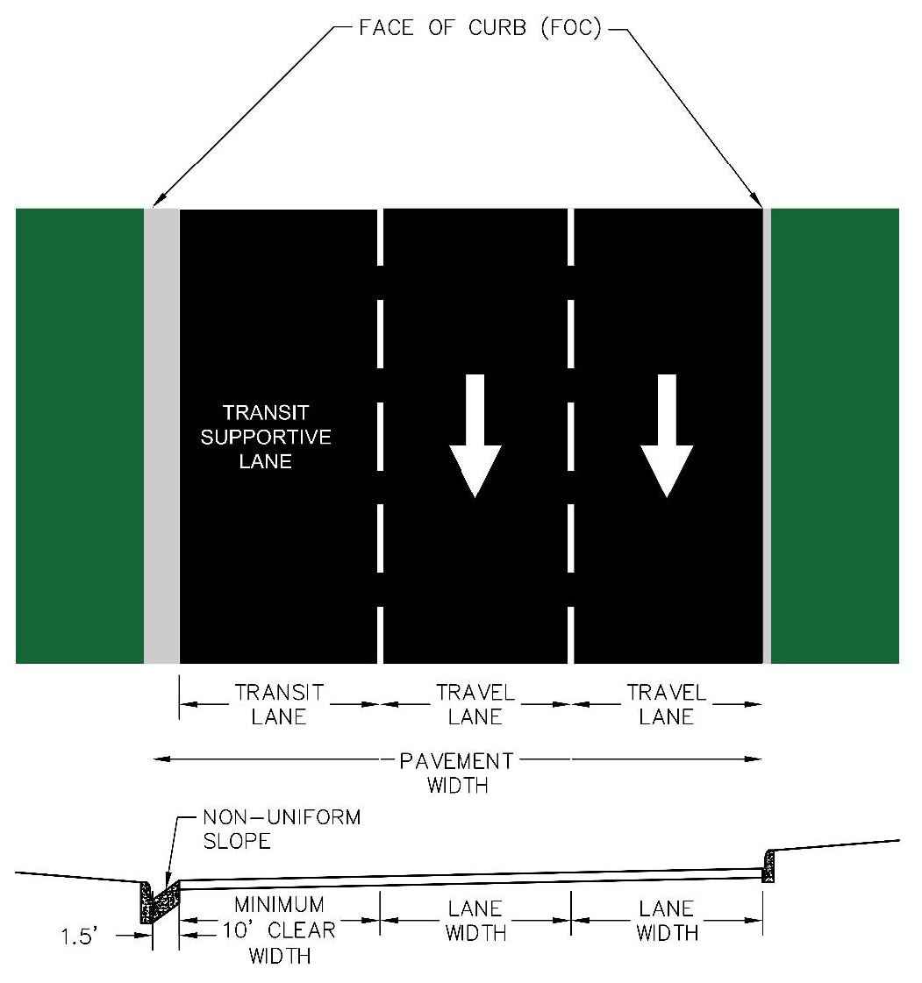
Figure 3-17 — Lane Width Dimensions and Edge Conditions
A. Lane widths are measured as width from the face of curb or center of pavement marking. Reference Table 2-2 for lane widths on curbed and guttered streets and Table 2-3 for non-curbed and guttered streets.
B. Level 2 Streets with transit traffic and Level 3 or higher streets shall have a clear width along the outside lane as shown in Figure 3-17.

3.5.4.2 Median Widths.
This section is only applicable to Level 3 and 4 Streets, with the exception of use at entryways to subdivisions on Level 2 Streets. The default treatment for lanes traveling in opposing directions is a physical curb with raised median. This treatment provides access control to manage turning conflicts and improve safety from all modes of travel. A physical curb and raised median are the safest treatment by separating travel directions and greatly reducing head on collisions while also providing space for errant vehicle redirection. Aside from the vehicular benefits, a raised median also improves safety for bicyclists and pedestrians by providing a protected space for crossing maneuvers by both users. Medians also provide a buffer for above and below ground utility placement. Landscaping and green street goals can also be accomplished within this space as well. Where a raised median cannot be provided, buffer space between opposing travel directions shall be provided with either a depressed median or pavement markings.
A. If lane is next to a lane carrying traffic in the opposing direction, additional lane width may be required per conditions in Section 2.
B. If a pedestrian crossing is provided through the median, see Section 4 on sizing requirements for pedestrian island areas.
C. Median width is measured at the mid-block typical section outside of turning lanes. The median width is intended to provide a recessed turn lane where possible.
D. Signs shall not be placed in the median when the width of the median next to a turn lane cannot comply with offset criteria in Section 11.
E. On streets that drain to the outside curbs, raised medians shall be built with 0.5 ft. gutter pans to maximize utilization of the cross-sectional space while providing a small gutter as a reference elevation for future pavement maintenance.
F. On streets where a median is proposed, consult with applicable staff on green street strategies planned for street as well as the Environmental Criteria Manual (ECM).
G. The minimum width for a median adjacent to a turn lane is 1 ft. as a back to back curb section. The minimum space required for a median turn lane, inclusive of back to back curb is 11 ft.

3.5.4.3 Cross Slope.
Cross slope is measured as the difference in grade perpendicular to the direction of travel, generally from the center or crown of the street to the edge of pavement. Figure 3-18 illustrates the required cross slopes by lane for divided and undivided streets. Examples of varied cross slope are the introduction of roadside gutter, curb, or variance from normal cross slope. Figure 3-17 shows various edge and median conditions and how lane widths are to be measured in design.
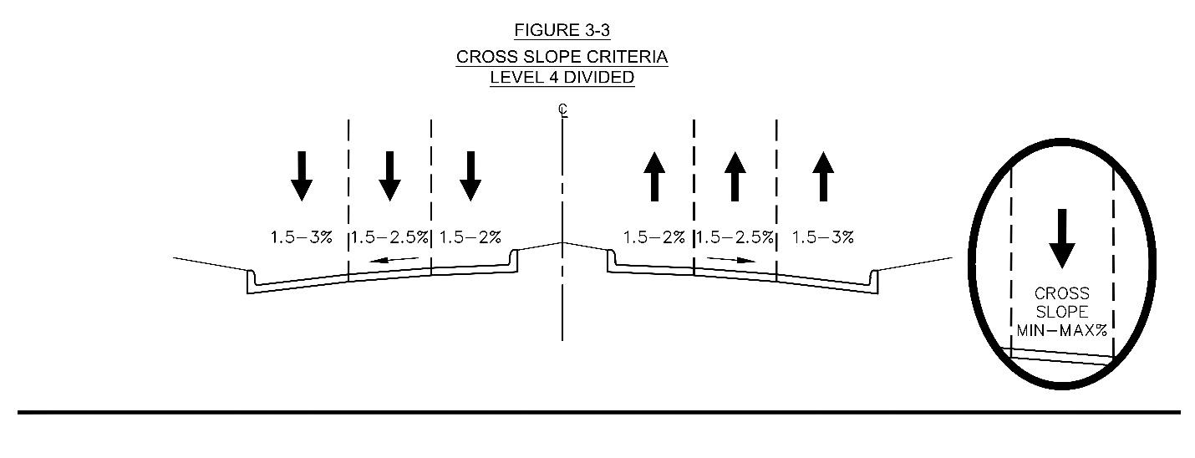
Figure 3-18 — Cross Slope
A. On undivided streets with no center turn lane and passing maneuvers, drivers cross and re-cross the crown line and negotiate a total rollover or cross slope change of up to 4%. The maximum algebraic difference between cross slopes in adjacent lanes, main lanes and auxiliary lanes shall be 4% for a crown or crest slope break.
B. On roadway sections that incorporate median islands, the difference in curb heights between the two interior curb lines may vary. In the area of intersections, median openings or possible median openings, the slope between the two interior curb tops should be no more than 2%.
C. Median openings are to be held to the same standard as for cross slopes because driveway connections may be made to produce a three- or four-legged intersection.
D. At an intersection, the lower Level Street shall super elevate to meet the longitudinal slope of the higher Level Street.
E. Within the intersection physical area (Section 3.6.4.1) it is desirable to reduce the cross slope of the street or super elevation the street in order to reduce minor street vehicles from vaulting as they cross intersection.
F. Use of superelevation will require City Transportation Engineer or applicable Director approval.

3.5.5 ADDITIONAL CONSIDERATIONS
Application of the street design criteria contained in this document to new subdivisions and site developments must take into consideration all applicable drainage and environmental standards, including restrictions on cut and fill and development setbacks from waterways and critical environmental features. Requirements of the street design criteria shall not be considered as sole justification for variances from the Chapter 25-7 (Drainage) or Chapter 25-8 (Environment) of the Land Development Code. Conversely, requirements of these chapters shall not be considered as sole justification for variances from street design criteria. It is advisable to delineate all floodplains, erosion hazard zones, required setbacks and other applicable environmental protection measures prior to designing streets. Refer to Title 30 of the City Code for additional considerations outside the Full Purpose Limits of the City of Austin.

3.5.5.1 Drainage Structures.
The location of stormwater control measures such as drainage structures, inlets, catch basins, etc., should be consistent with the intended use of the right-of-way and in accordance with the Drainage Criteria Manual.
A. Inlets or catch basins shall not be located within the corner radius or within 10 ft. from the point of curvature of the corner radius or within 10 ft. of driveways.
B. A 5 ft. clearance is needed to allow space for traffic control devices, utilities, and accessible pedestrian facilities

3.5.5.2 Utility Assignments.
Space is generally provided for above ground utilities and street lighting in the pedestrian zone as defined in Section 2.6.0. Placement of utilities above ground and below ground level shall be in accordance with the Utilities Criteria Manual and Drainage Criteria Manual. Below ground utilities are preferred for maximization of landscaping, street trees and space for street elements.

3.5.5.3 Environmental Considerations.
Deviations from the street design criteria may be applied for, on a case-by-case basis, in order to protect specific environmental features on severely constrained tracts provided that proposed deviations meet minimum safety standards, balance safety of all modes, and are approved by the City Transportation Engineer or applicable Director. General deviations may be pursued as stated in the Section 1 of this Manual. See the Environmental Criteria Manual for environmental design standards.

3.6.0 INTERSECTION DESIGN
This section governs design criteria for intersection designs of crossing streets that are Level 2 or higher. Refer to Section 3.4.2.1 for intersection with Level 1 Streets, referred to as Minor Street Crossings. The goal of every intersection is to provide safe passage and crossing of all users of the street. Enhanced and clearly visible space for pedestrian and bicyclists, geometrics to reduce vehicular turning speed, clear sight lines for turning vehicles, and spacing along the street must all be considered and balanced during design of intersections. The intent of intersection design is to create a space that adheres to the guidelines set forth by Vision Zero, with a goal of achieving zero traffic related deaths in the City.
The intersection is a pivotal point where different street designs intersect - resulting in the most potential for conflicts between the trade-offs being considered. Intersections are also typically transition areas for Street Levels, where modal facility design often changes, and number of motor vehicle lanes may increase or decrease.

3.6.1 SAFETY & MULTI-MODAL CONSIDERATIONS
As non-vehicular traffic continues to rise along streets as part of the City's 50-50 mode split goal defined in the ASMP, intersections must not simply consider the crossing maneuvers of vehicles as the primary criteria for design. As outlined in NACTO's Don't Give Up at the Intersection guide, 43% of urban bicyclist fatalities occurred at an intersection. The primary components of improving safety for non-vehicular users consist of reducing turn speeds and improved visibility. Protected space must be reserved for both bicyclist and pedestrians queuing and crossings at all intersections.
As the diversity of street users changes the design of intersections must accommodate all street users. This section establishes standard treatments for how to transition and cross bicyclist and pedestrians at signalized and unsignalized intersections. These treatments are to be used for intersection design in new construction, reconstruction, and retrofit projects. Further guidance on pedestrians and bicyclist facilities within the right-of-way are covered in Section 4 and Section 5 respectively.
The design of bike lanes, sidewalks, or shared-use paths approaching and traversing through intersections must clearly communicate right-of-way to improve safety for these vulnerable non-vehicular users. The criteria listed in this section greatly reduce turning speeds and visibility when compared to intersection treatments historically applied to accommodate vehicles. For further criteria on visibility and sight distance at intersections refer to Section 3.4.2.1.1.
Refer to the City of Austin Standard Details for additional detail on the various example intersection design figures in this section.

3.6.1.1 Bicycle & Pedestrian Transitions and Crossings.
When non-vehicular modes of travel are separated prior to the intersection, protected intersections shall be the standard intersection design. Protected intersections physically separate people walking, bicycling, and motor vehicles, reduce motor vehicle turning speeds, create intermediate crosswalk waiting areas, and provide motorist yield zones using corner islands. These various features reduce the number of conflict points or reduce speed at conflict points. Protected intersections are compatible with streets with either protected bicycle lanes or legacy painted bicycle lanes through transitioning bicycle facilities behind curb. Figure 3-19 and Table 3-13 contain the protected intersection configuration, features, and required dimensions for each feature.
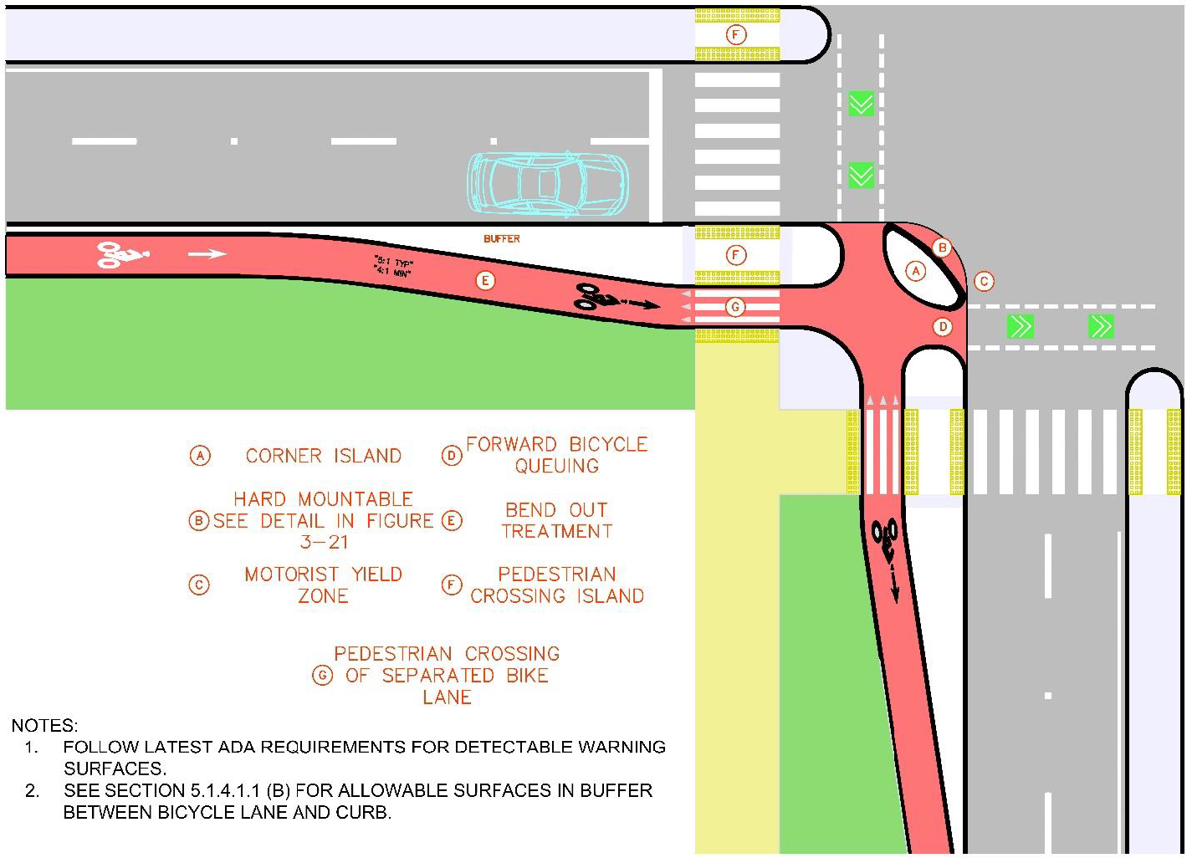
Figure 3-19 — Protected Intersection Configuration
Table 3-13 — Protected Intersection Feature Dimensions
Intersection Element | Size Requirement
A - Corner Island | See Section 3.6.2.2; by Turning Simulation and Corner Space
B - Corner Mountable Apron | See Section 3.6.2.2; by Turning Simulation
C - Motorist Yield Zone | 6 ft. - 16.5 ft. (dimensioned from edge of outside lane to inside edge of bike lane)
D - Forward Bicycle Queuing | 6 ft. x 6 ft.
E - Bend Out Treatment | 5:1 Typical Lateral Taper, 4:1 Minimum Lateral Taper
F - Pedestrian Crossing Island | 6 ft. Deep x 5 ft. Wide
G - Pedestrian Crossing of Separated Bike Lane | Dimension "W" in Section 4.2.4.2
H - Bicycle Conflict Area | 8 ft. Wide

A. Protected intersections shall be designed in accordance with Figure 3-19 and each element of the intersection shall be designed based on the requirements in Table 3-13.
B. Street Level bicycle facilities shall be transitioned to be behind a curb or edge of pavement prior to crossing an intersection.
C. Vertical transitions shall be 4% slope per Section 5.1.1.2.

3.6.1.2 Shared Use Paths at Intersections.
When non-vehicular modes are not separated prior to the intersection or shared use paths are used for non-vehicular travel, crossings shall accommodate mixed flow of bicycles and pedestrians. Shared Use Path design criteria can be found in Section 5.
A. Transitions for the non-separated bike lanes shall occur prior to the shared use areas.
B. Transitions from separated pedestrian and bicycle facilities to shared use areas shall include a detectable warning surface extending the full width of the shared use area at the transition point. Standards for detectable warning surface details are located in the City of Austin Standard Details.

3.6.1.3 Pedestrian Islands at Intersections.
The design of this space must consider the vehicles that will be turning at the intersection to ensure a protected space for pedestrians. When pedestrian island areas are used at midblock crossings refer to Section 4.2.4.2 for more guidance. Refer to City of Austin Standard Details for median nose construction and mountable details when used in design.
A. Pedestrian islands shall be completely outside of the area of the emergency control vehicle swept path.
B. Pedestrian crossings shall be placed as close to the intersection as possible and minimize horizontal deflection in pedestrian paths.
C. When turning movement of control vehicles encroaches on median nose, mountable median treatments may be used.

3.6.2 INTERSECTION GEOMETRICS
The geometric design of an intersection creates the space for vehicles, pedestrians, and bicyclists to traverse the intersection safely. The geometrics of the intersection influence the speeds of turning vehicles. Intersections must be designed as compactly as possible, in acknowledgement that they serve many modes and must consider safety as the highest priority at conflict points. Intersections are to be designed to provide protected space for pedestrians and bicyclists wherever outside of a travel lane. This is accomplished by a combination of bulb-outs and physical medians. Compact intersections slow traffic near conflict points, increase visibility of all users, and reduce pedestrian crossing distances. An additional benefit of compact intersections are reduced crossing times at signalized intersections, providing more efficient operation for vehicles.
A. At intersections of rights-of-way, additional right-of-way shall be dedicated per the ASMP. In addition, intersections of rights-of-way shall be cornered with a radius matching the recommended curb radius per Section 3.6.2.2 or a corner clip with the length along each right-of-way equal to the recommended curb radius.

3.6.2.1 Bulb-outs.
Bulb-outs shall be constructed into any cross-sectional street elements that contains parking to shorten pedestrian crossings, control vehicle speeds, and increase the visibility of crossings. Depending on the presence of parking, the width of the street, and the Street Levels being intersected the configuration for bulb-outs can differ. Bulb-outs shall be located at intersections to slow turning movements. The geometry of the bulb-outs are to be designed around the turning movements of the normal traffic as discussed in Section 3.6.2.2. Further design guidance for bulb-outs is included in Section 4.2.4.1.

3.6.2.2 Turning Movement Analysis.
This section governs the analysis and use of vehicular turning movements to design intersections. Turning movement analysis using computer aided design software is required for intersection designs where control vehicle or turn behavior differ from the parameters in this Section. Exhibits documenting this analysis shall be submitted with all engineered design plans that deviate from the criteria in this Section. Turning movements design criteria are outlined in Table 3-14 and Table 3-15 and shall not be deviated from unless approved by applicable staff. Figure 3-20 illustrates different cases for turning movements shown in the remainder of this section and as referenced in Table 3-14 and Table 3-15. Section 3.2.1 specifies how design and control vehicles should be used in design of streets. See City published administrative guidelines which include turning templates used in development of these criteria .
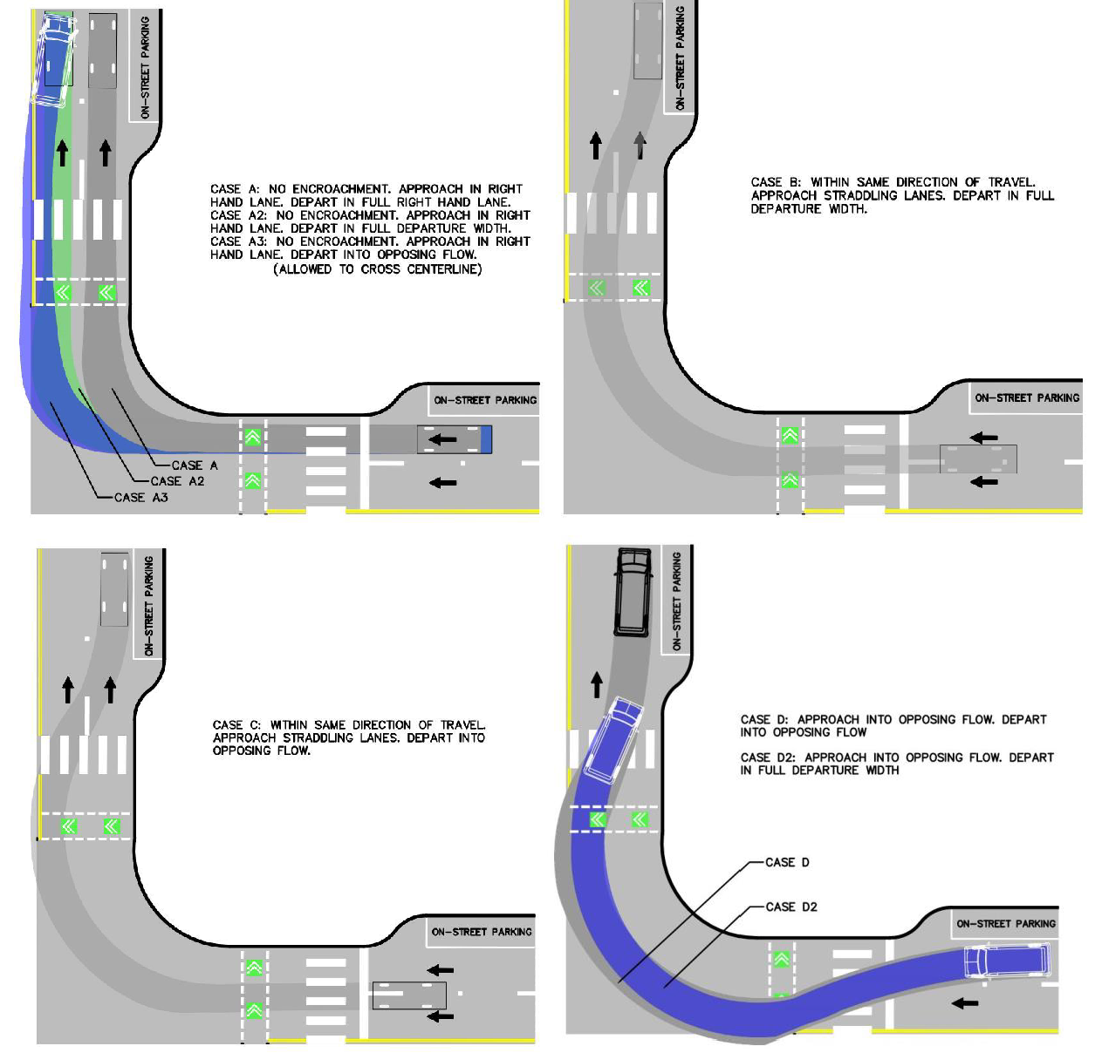
Figure 3-20 — Turning Movement Encroachment Cases
Table 3-14 — Control Vehicle & Case by Street Level
 |  | Receiving Street Level
 |  | 4/5^{B} | 3^{A} | 2 | 1
Departing Street Level | 4/5^{B} | WB-50 (B)  Quint (B) | WB-50 (B)  Quint (B) | DL23 (A3)  Quint (C) | DL23 (A3)  Quint (C)
Departing Street Level | 3^{A} | WB-50 (B)  Quint (B) | WB-40 (B)  Quint (B) | DL23 (A3)  Quint (C) | DL23 (A3)  Quint (C)
Departing Street Level | 2 | DL23 (A2)  Quint (D) | DL23 (A2)  Quint (D) | DL23 (C)  Quint (D2) | DL23 (A2)  Quint (D2)
Departing Street Level | 1 | DL23 (D)  Quint (D) | DL23 (D)  Quint (D) | DL23 (D)  Quint (D2) | Quint (D2)
^{A} Control vehicle can be changed to a smaller vehicle with a single lane Level 3.
^{B} These control vehicles are also to be applied to frontage roads and highways.

Table 3-15 — Recommended Effective Radii (Min - Max)^{A, C, D, F}
 |  | 4/5^{B} | 3 | 2 | 1
Departing Street Level | 4/5^{B} | 30 ft. (25—35 ft.) | 25 ft. (25—35 ft.) | 15 ft. (15—20 ft). | 15 ft. (10—20 ft.)
Departing Street Level | 3 | 25 ft. (25—35 ft.) | 20 ft. (20—25 ft.) | 15 ft. (15—20 ft.) | 15 ft. (10—20 ft.)
Departing Street Level | 2 | 15 ft. (15—20 ft.) | 15 ft. (15—20 ft.) | 15 ft. (10—20 ft.) | 15 ft. (10—15 ft.)
Departing Street Level | 1 | 15 ft. (10—20 ft.) | 15 ft. (15—20 ft.) | 15 ft. (10—15 ft.) | 15 ft. (10—15 ft.)
^{A} Radii are affected by angle of intersection. Values shown in this table assume generally orthogonal intersections. Values for skewed intersections will vary and need to be determined with turning simulation.
^{B} These recommended radii are desired for frontage roads and highways.
^{C} Presence of medians can result in different radii or mountability of median.
^{D} Actual radius may be smaller than the effective radius depending on receiving street width and presence of in-street bike lanes, parking, and bulb-outs.
^{E} Assumes a multi-lane Level 3 street. If designing single lane median divided street, turn design analysis required.
^{F} Corners where right turns are not permitted shall have radii of 5 ft. or less.

A. Design vehicle shall be a passenger car and turn using Case A, with the exception of an intersection of two Level 1 Streets when the turn shall be Case C.
B. Control and design vehicle resulting radii may be modified at the discretion of the City Transportation Engineer or applicable Director. The lower end of the range shall be used unless larger radii is needed and analysis provided to justify the larger radius.
C. When the following conditions are present for turning movements, the passenger car design vehicle shall be superseded by the stated design vehicle in these criteria and recommended curb radii do not apply for right turns:
1. On Transit Priority Corridors or where a designated transit route uses a right or left turn at an intersection, the design vehicle shall be a Standard City Bus using Case A2.
2. Other than Level 1 Streets, where a school bus makes right or left turns as part of its regular route, the design vehicle shall be a school bus using Case A3.
D. To accommodate a control vehicle, the following design strategies may be used with approval by applicable staff:
1. Stop bars may be setback from the intersection up to 30 ft.
2. Corners may be mountable for emergency control vehicles.
3. Median noses and pedestrian or median islands may be mountable.
E. Dual left turns shall not be permitted where there are 2 receiving lanes and the outside receiving lane includes a far side bus stop within 200 ft. of the intersection, which may block vehicles from making the inside left turn.
F. Dual left turns shall accommodate both lanes turning to the inside receiving lanes when more than 2 receiving lanes are present.
G. Design vehicle turning movements are to be analyzed at 10 mph. If the recommended radius in Table 3-15 cannot be accommodated, the turning speed may be reduced to 5 mph.
1. Left turn speed may be analyzed at 15 mph if at a traffic signal, but may be reduced to 10 mph to allow a median nose or pedestrian waiting area.
H. Control vehicle turning movements are to be analyzed at 5 mph. If the control vehicle cannot be accommodated at 5 mph, the turning speed may be reduced to 1 mph or alternative strategies used per criteria (D).
I. For left turn movements, median noses shall be designed per City of Austin Standard Details. Deviations from the geometry shown in the standard details is allowed if it allows completion of design or control vehicle turning movement, such as use of a bullet nose median, and does not conflict with pedestrian or bicyclist crossings. For right turn movements, the curb return shall be designed to follow the vehicle wheel path.
1. Semicircular radii may be used on the noses of medians up to 6 feet wide. Compound medians nose treatments should be used for medians of greater width which gives enhanced opportunity for a median nose pedestrian waiting area.
J. Compound curves shall be used for turning movement design to best fit the wheel path. Raised bulb-outs and medians shall be used to increase pedestrian waiting areas and reduce turning space.
K. Areas where the apparatus body envelope of the control vehicle is anticipated to pass behind the face of curb or edge of pavement shall be clear of any vertical obstructions under 8 ft. height.

3.6.2.2.1 Mountable Surface Placement.
Intersection layouts shall incorporate the design control radius listed in Table 3-15. In scenarios where an existing intersection is being modified to include an additional turn lane or where right-of-way is constrained and the control radii in Table 3-15 cannot be incorporated, implementation of mountable median noses may be used to maintain a raised barrier separating traffic.
A. For streets with one travel lane in each direction and a center median, medians adjacent to a turn lane shall be either mountable surface or flush with the street pavement to allow for larger vehicles to make turns.
B. Engineered mountable surfaces shall be placed between the edge of the design vehicle wheel path and the wheel path of the control vehicle. For left turns, standard median noses must be installed with a mountable curb.
C. Figure 3-21 illustrates the profile of a mountable curb to accommodate a control vehicle. Refer to City of Austin Standard Details for additional design details on mountable median noses and mountable curbs.
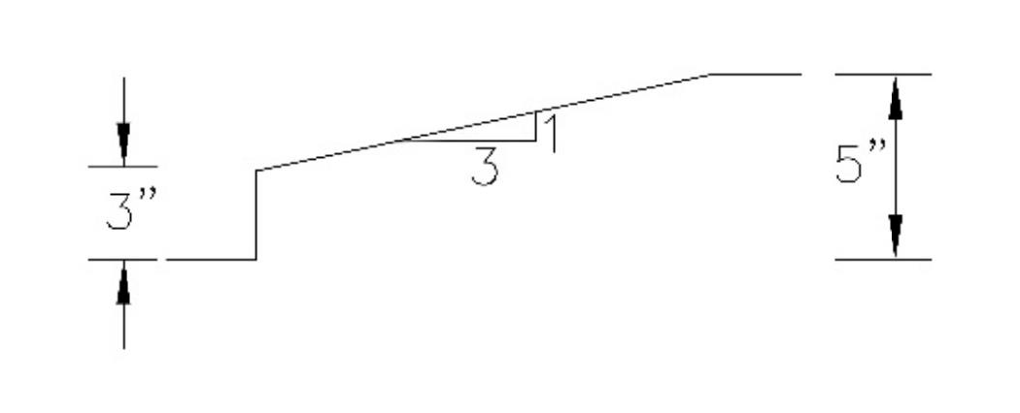
Figure 3-21 — Mountable Curb Profile

3.6.3 TURN LANES
This section covers the design of turn lanes on all new streets. While turn lanes improve intersection efficiency, they also introduce a conflict point between on street bicycle facilities and lengthen pedestrian crossing distances. Dedicated left and right turns shall only be provided along Level 2 and higher streets where turning volumes warrant their inclusion in street design. Turn lanes will not be considered unless volumes meet thresholds in Table 3-16 determined through a Transportation Impact Analysis as defined in Section 10.
Table 3-16 — Turn Lane Thresholds
Turn Lane Type | Volume Threshold (turning vehicles per hour projected)
Right Turn Lane | 200
Single Left Turn Lane^{A} | 150
Dual Left Turn Lane^{B} | 300
^{A} Threshold is not necessary if center turn lane or median with adequate width for a left turn lane per Section 3.5.4.2 is present and access is approved by applicable department.
^{B} Shall only be considered where widening is feasible to accommodate and maintain minimum street element widths per Section 2.

A. Turn lanes must provide sight distance for vehicular traffic to oncoming traffic and pedestrians and bicyclists. See Section 3.4.2.1.1 for further guidance on intersection sight distance.

3.6.3.1 Left Turn Lanes.
Left turns shall be offset from adjacent travel lanes when sight distance is obstructed from opposing left turns or sight distance obstructions to maximize visibility for left turning vehicles. The typical configuration of the left turn offset in a median is shown in Figure 3-22. Two-way left turn lanes are strongly discouraged and should only be provided when approved as they introduce unprotected conflict points between drivers. Dual left turns create a number of impacts that need to be carefully considered and approved by applicable staff. Turn lane elements and dimensions are contained in Figure 3-23. Table 3-17 contains design criteria for unsignalized left turn lanes. Signalized left turns shall be evaluated in a Transportation Impact Analysis per Section 10.
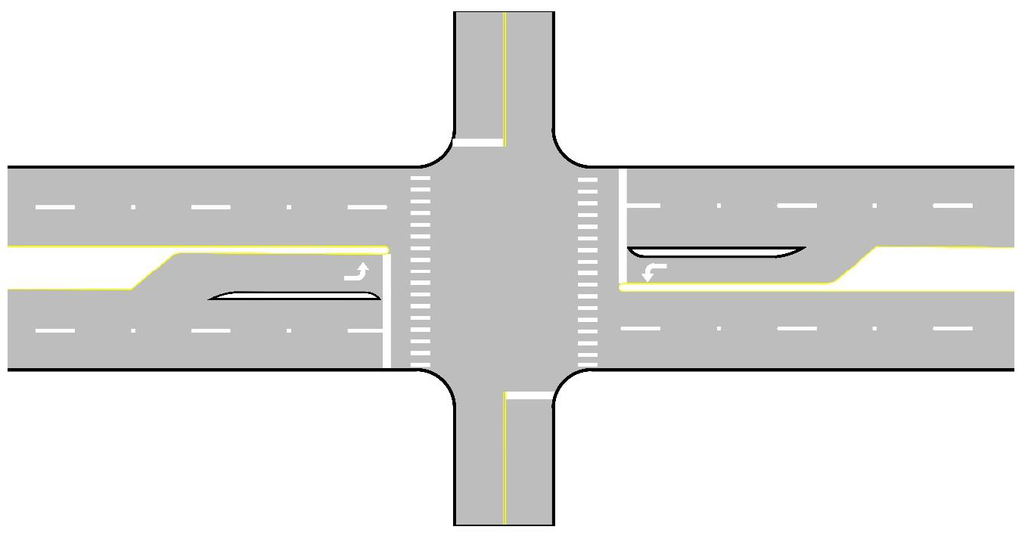
Figure 3-22 — Positive Offset Left Configuration
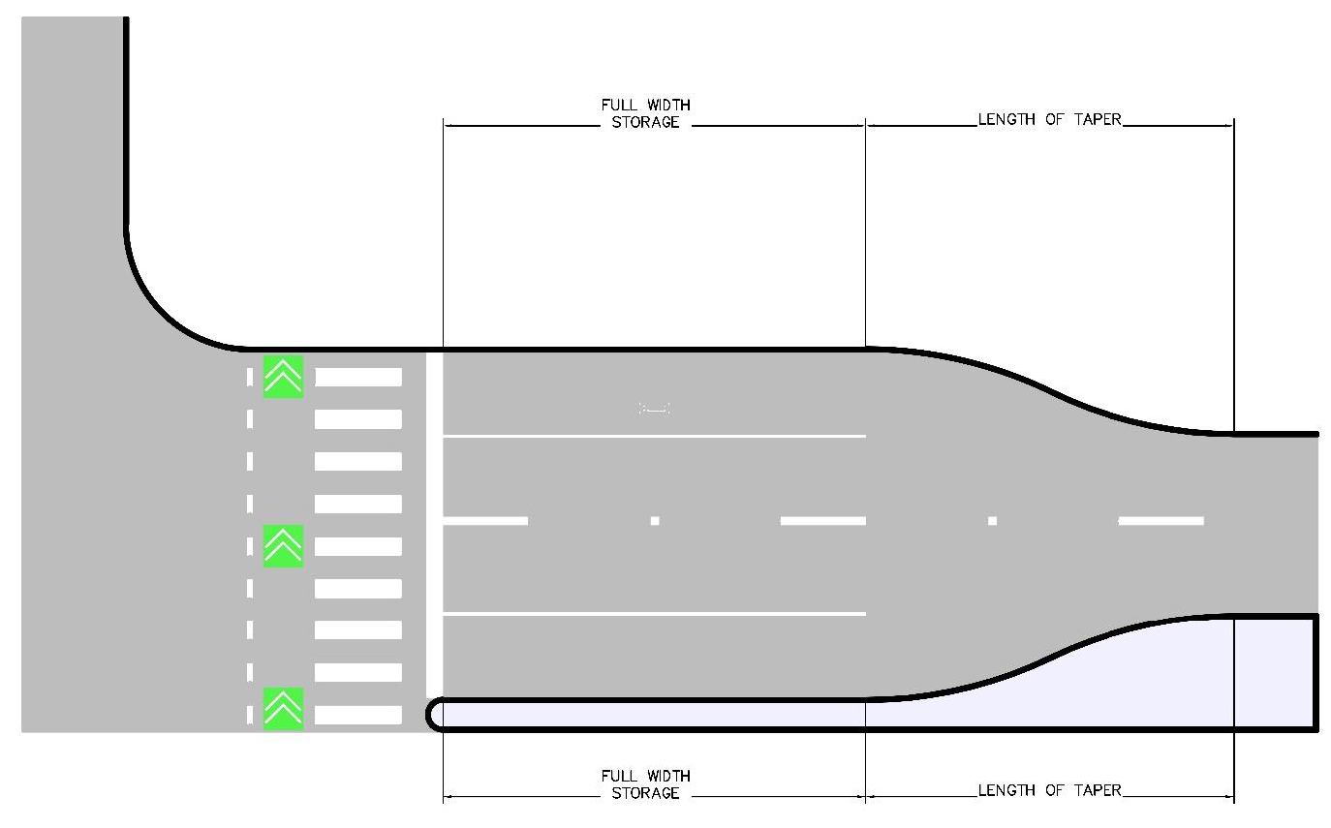
Figure 3-23 — Negative Offset Left Configuration
Table 3-17 — Unsignalized Left Turn Design Criteria
Level of Street On | Level of Street At | Turn Lane Width (ft.) | Length of Full-Width Storage (ft.) | Taper  Specifications
4 | 4,3 | 10 | 250 | 200
3 | 4,3 | 10 | 150 | 200
4,3 | 2 | 10 | 150 | 100
4,3 | 1 | 10 | 100 | 100
4,3 | Median Opening | 10 | 150 | 100
2,1 | 4,3,2,1 | 10 | 100 | 100

A. At left turn signalized intersections, the storage length shall be long enough to accommodate the projected 95th percentile queue length as determined by the Highway Capacity Manual (HCM). At any left turn signalized intersection, a traffic study must be performed by a licensed professional engineer to determine the left-turn storage length, exclusive of taper, based on the number of turning vehicles likely to arrive in an average 2 minute period within the peak hour with each vehicle accounting for approximately 25 ft. of storage. Turn lanes that exceed 400 ft. must be approved by the City Transportation Engineer or applicable Director.
B. To ensure proper deceleration length for turn lanes, the taper length plus storage length shall exceed deceleration length for a speed differential of 20 mph by at least 50 ft., per deceleration lengths in the latest edition of the TxDOT Roadway Design Manual.
C. Dual left-turn lanes can be considered where traffic volumes exceed the capacity of a single lane and the cross-street is of sufficient width to receive 2 vehicles turning side by side.
i. Dual left-turn lanes are not permitted if only two receiving lanes are present with a bus stop within 200 ft. of the intersection.
ii. Dual lefts require protected phasing that precludes permissive lefts/flashing yellow left signal operations.
iii. Dual lefts require exclusive pedestrian phases that depending on degree of pedestrian activity can affect theoretical signal benefits.
D. Dual right-turn lanes are not permitted unless approved by staff member of the applicable department.
E. If a turn lane falls in line with future through lane, width of turn lane shall match future through lane width.

3.6.3.1.1 Two-Way Left Turn Lane (TWLTL).
Refer to Section 2 for permitted widths and applications of TWLTL. Due to the adverse safety impacts from head on conflict points that are created these turn lanes are highly discouraged. Where installed, raised medians are to be used where turning movements are not required to eliminate continuous TWLTL. This treatment is permitted as a retrofit application where high density access arises and is required for efficient operation of street.
TWLTL are not permitted for new construction projects unless approved by the City Transportation Engineer, applicable Director, or their designee.

3.6.3.2 Right Turn Lanes.
If a right turn lane is warranted per Table 3-16, it shall be designed as a smart right turn. Smart rights, by design, create a pedestrian island space prior to the turning vehicle path which reduces crossing distances and makes pedestrians highly visible to motorists. Smart rights facilitate the safe and orderly crossings between vehicles, pedestrians, and bicycles. Figure 3-24 illustrates a smart right turn lane and its features.
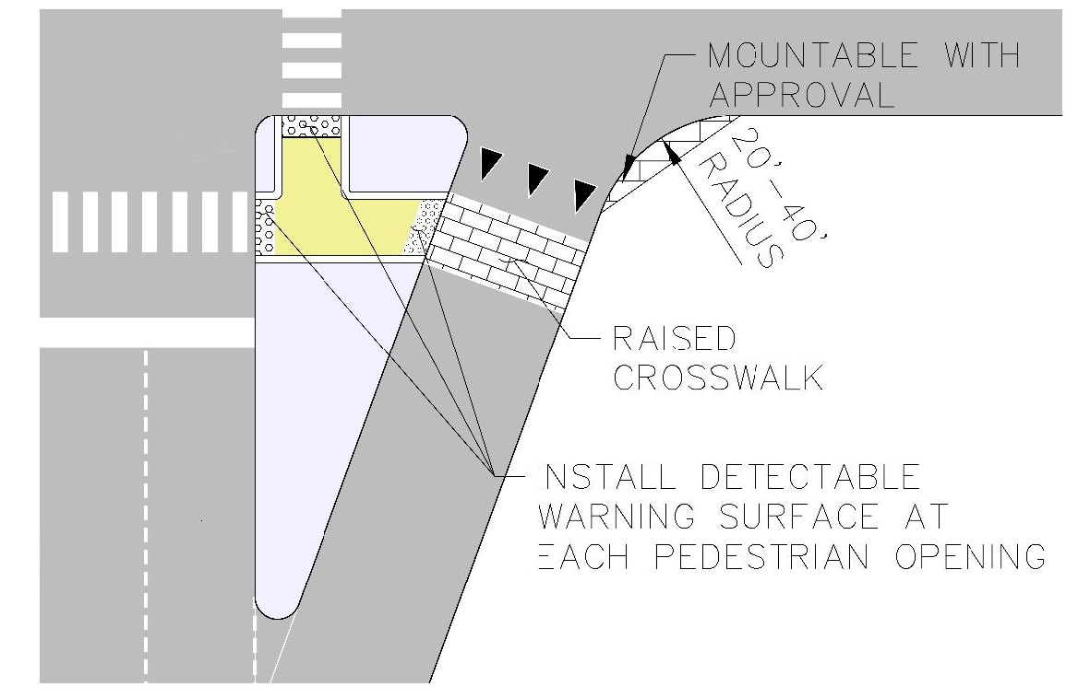
Figure 3-24 — Smart Right Turn
A. Sight distance analysis shall be performed as outlined in Section 3.4.2.1.1.
B. Pavement markings shall be used to supplement raised islands or other forms of physical separation of motor vehicles and other users of intersections and shall not be used as the only form of demarcation for channelizing right turns.
C. Yield condition or stop sign must be provided at all smart rights. Uncontrolled turning movements are not permitted unless approved by staff member of applicable department.
D. Pedestrian crossings for channelized right turns shall be a raised crosswalk.
E. Smart right turn design entry and turning speed shall be at a target speed of 10 mph or less, for the appropriate design vehicle and control vehicle.
F. Channelizing islands should include adequate space for accessible pedestrian paths and be compliant with ADA guidelines for design.

3.6.4 INTERSECTION PROFILE & APPROACH DESIGN
Approaches to intersections serve to facilitate various maneuvers for road users such as lane shifts, merges, and turning movements. Approaches also serve the intersection by maintaining storage capacity for turning movements while vehicles wait for a safe opportunity to make a turning maneuver and not block lanes that are free flowing.

3.6.4.1 Intersection Physical Area.
The intersection physical area is defined by the area in which the intersecting roadways, driveways, pedestrian access routes and bikeways overlap and is shown in Figure 3-25. This area is primarily governed by vertical alignment, horizontal alignment, and minimum curb radius dimensions.
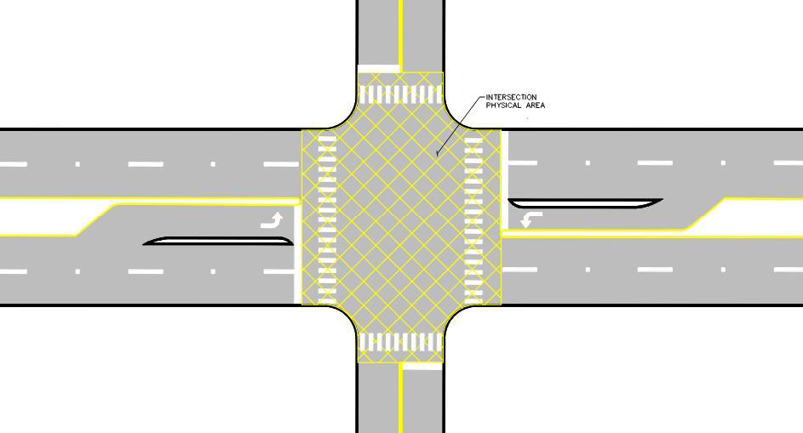
Figure 3-25 — Intersection Physical Area

3.6.4.2 Intersection Alignments and Features.
A. In the intersection physical area, the target speed for motor vehicles for the higher level street at any intersection shall be maintained through the intersection approaches unless traffic calming and appropriate advance warning signage is used.
B. The horizontal cross slope within the intersection physical area shall be a flat grade, where possible, that allows for street drainage. In situations where the terrain does not allow for flat grade, a maximum cross slope of 2% should be maintained for pedestrian access routes.

3.6.4.3 Horizontal Alignment for Intersection Approach.
Figure 3-26 illustrates the tangent length requirement for intersection approaches.
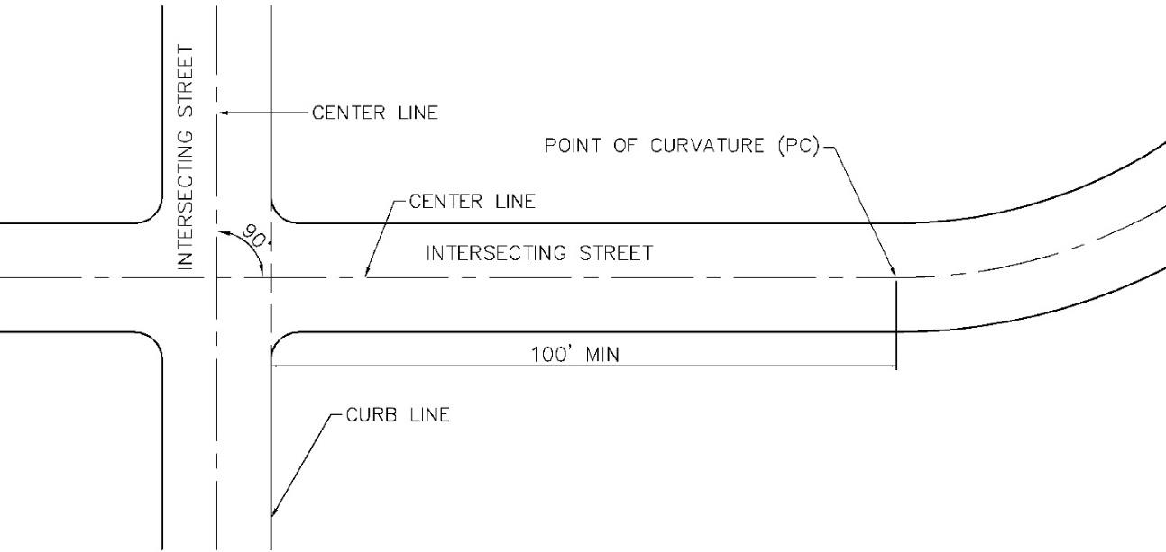
Figure 3-26 — Intersection Approach Geometry
A. The horizontal approach to an intersection shall be tangent for a minimum length of 100 ft. Longer tangents are highly desirable.
B. The tangent distance is measured from the curb line of the higher-Level street to the first point of curvature on the intersecting street. In this regard, radii greater or equal to 1,000 ft. may be considered tangent.
C. Intersections shall meet at approximately a 90-degree angle. Skewed intersections shall require City Transportation Engineer, applicable Director, or their designee's approval and in no case should the angle be less than 80 degrees or greater than 100 degrees.

3.6.5 ACCESS SPACING
This section governs spacing guidelines for placement of intersections and median openings along all streets. These criteria apply to new streets where access can be controlled and spaced prior to street construction. Planning access management for new projects is critical for a future well connected and safe street network. Spacing is to be planned in conjunction with adjacent development projects and zoning areas. New street intersections placement shall be placed in such a way to align with existing streets and minimize left turn conflicts. Median openings on new streets shall be placed at regular intervals to encourage a compact and connected street network. Access management shall be provided for in design of all Level 2 and higher streets. For placement of driveways in relations to median openings and intersections, see Section 7.
Table 3-18 shows the required access spacing based on target speed of the street being designed. Spacing requirements are further broken down by the level of activity along the street and if turn lanes are warranted at median openings. Where turn lanes are not required for access, median openings can be placed closer together. Figure 3-27 illustrates measurement of median opening spacing and Section 7 elaborates further on driveway placements.
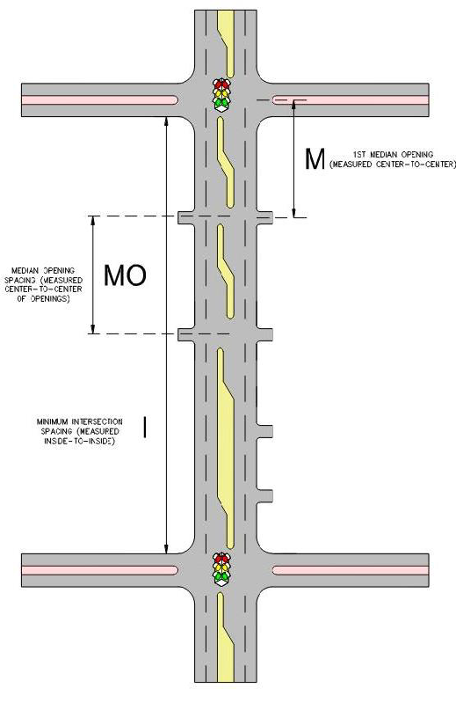
Figure 3-27 — Access Spacing
Table 3-18 — Median Opening Spacing Design Criteria
Street Level (mph) | Target Speed | Minimum Intersection - Intersection Spacing (ft.) "I" | Minimum Intersection to Median Opening Spacing (ft.) "M" | Minimum Median Opening - Median Opening Spacing (ft.) "MO"
 |  |  |  | No Turn Lane Required | Turn Lane Required
Level 3 High Activity | 25 | 600 | 300 | 150 | 300
Level 3 Low Activity | 30 | 700 | 350 | 200 | 350
Level 4 High Activity | 35 | 1,000 | 500 | 250 | 400
Level 4 Low Activity | 40 | 1,000 | 500 | 350 | 500

A. Median openings shall only be provided if minimum turn lane tapers and storage can be provided as outlined in Section 3.6.3.1. Median openings with substandard taper and storage length can only be provided with approval of staff member from the applicable department.
B. Where minimum spacing requirements cannot be met along high-density corridors in urban areas, substandard spacing is permitted with approval of applicable staff. Median openings can be reduced to 300 ft. minimum.
C. Public streets shall be designed so that the centerline of the street is directly across from the centerline of another existing public street if left turns are permitted into or out of the public street.
D. If an intersection is offset, they shall be located to avoid conflicting left turns and placed a minimum of 30 ft. apart measured from the center line intersection of an intersecting roadway and the centerline intersection of the adjacent intersecting roadway, measured along the centerline of the intersected roadway.
E. If an intersection is offset and left turns will conflict, access shall be restricted to right-in, right-out, with the exception of a hooded left-turn onto a street.
F. Full-function median openings on Level 3 and higher streets shall be allowed only where the minimum spacings for signalized intersections are practicable. Practicable spacing outside the central business district are assumed to be 1,000 ft. Consult with applicable staff for allowable spacing in the CBD.
G. At intermediate locations along Level 3 and higher streets, limited-function openings may be provided at the spacings listed in Table 3-18.

3.6.6 TRAFFIC SIGNALS
A. Traffic signals shall be designed in compliance with the requirements set forth in the TMUTCD.
B. All signal design shall conform to standard specifications and standard details as shown the Standard Specifications Manual and Standards Manual.
C. All traffic signals shall be approved by the City Transportation Engineer or applicable Director.

3.6.7 ROUNDABOUT GEOMETRIES
A roundabout is a form of circular intersection in which traffic travels counterclockwise around a central island and in which entering traffic must yield to circulating traffic. Roundabouts are a subset of circular intersections with specific design and traffic control features. These features include yield control of all entering traffic, channelized approaches, geometric curvature, and features to induce desirable vehicular speeds.
Chapter 6 of NCHRP Report 672 should be used for geometric design of roundabouts, construction details, spacing between roundabouts, and traffic control plan phasing in the City of Austin. Key criteria that should be met include fastest path entry speeds, design vehicle movements, path overlap for entry and exit tangents, entry angles, entry and exit radii, maximum and minimum slopes and several other factors that are detailed in the NCHRP Report 672. Reference Section 4.2.4.2 for Pedestrian island area minimum dimensions at roundabouts. Inscribed circle diameters should be designed as shown in Table 3-19. It is not preferred to apply signalized treatments to roundabouts.
Roundabouts can be one of many types: mini-roundabout, single lane roundabout, multi-lane roundabout, and roundabouts with bypass lanes. Roundabouts should be designed with the conditions shown in Table 3-19 for the appropriate category of roundabout based on available space, number of entering lanes and target speed, adapted from NCHRP Report 672. Typical configurations and features of each category of roundabout are shown in Figure 3-28 through Figure 3-31.
Table 3-19 — Roundabout Categories
Design Element | Roundabout Configuration
Design Element | Mini-Roundabout | Single-Lane Roundabout | 2 Lane Roundabout
Desirable entry target speed | 15—20 mph | 20 mph | 20—25 mph
Maximum number of entering lanes per approach | 1 | 1 | 2+
Central island treatment¹ | Hard Mountable | Raised (may have traversable truck apron) | Raised (may have traversable truck apron)
Central island pedestrian waiting area length | varies | 6 ft. minimum | 8 ft. minimum
Pedestrian/Bicycle Facilities | 8 ft. Shared Use Path | Separated sidewalk and protected bicycle lane or 10 ft. shared Use Path | Separated sidewalk and protected bicycle lane or 12 ft. shared Use Path
Pedestrian/Bicycle Crossings² | Raised crossing with pedestrian warning signs | Raised crossings with flashing pedestrian warning signs | Grade separation or raised crossings with RRFB
Typical daily service volumes on 4-leg roundabout below which may be expected to operate without requiring a detailed capacity analysis (veh/day) | Up to approximately 15,000 | Up to approximately 25,000 | Up to approximately 45,000 for two lane roundabouts
Design Vehicle | Common Inscribed Circle Diameter Range*
SU-30 | 45—90 ft. | - | -
B-40 | - | 90—150 ft. | -
WB-50 | - | 105—150 ft. | 150—200 ft. (180—250 ft.)
WB-67 | - | 130—180 ft. | 165—200 ft. (180—300 ft.)
¹ Hard mountable curb profile is 3 in. vertical and 2 in. additional at 3:1 slope.
² For multilane roundabouts grade separation is recommended. For roundabouts with three lanes or two lane and designed for speeds over 20 mph, grade separation is required.

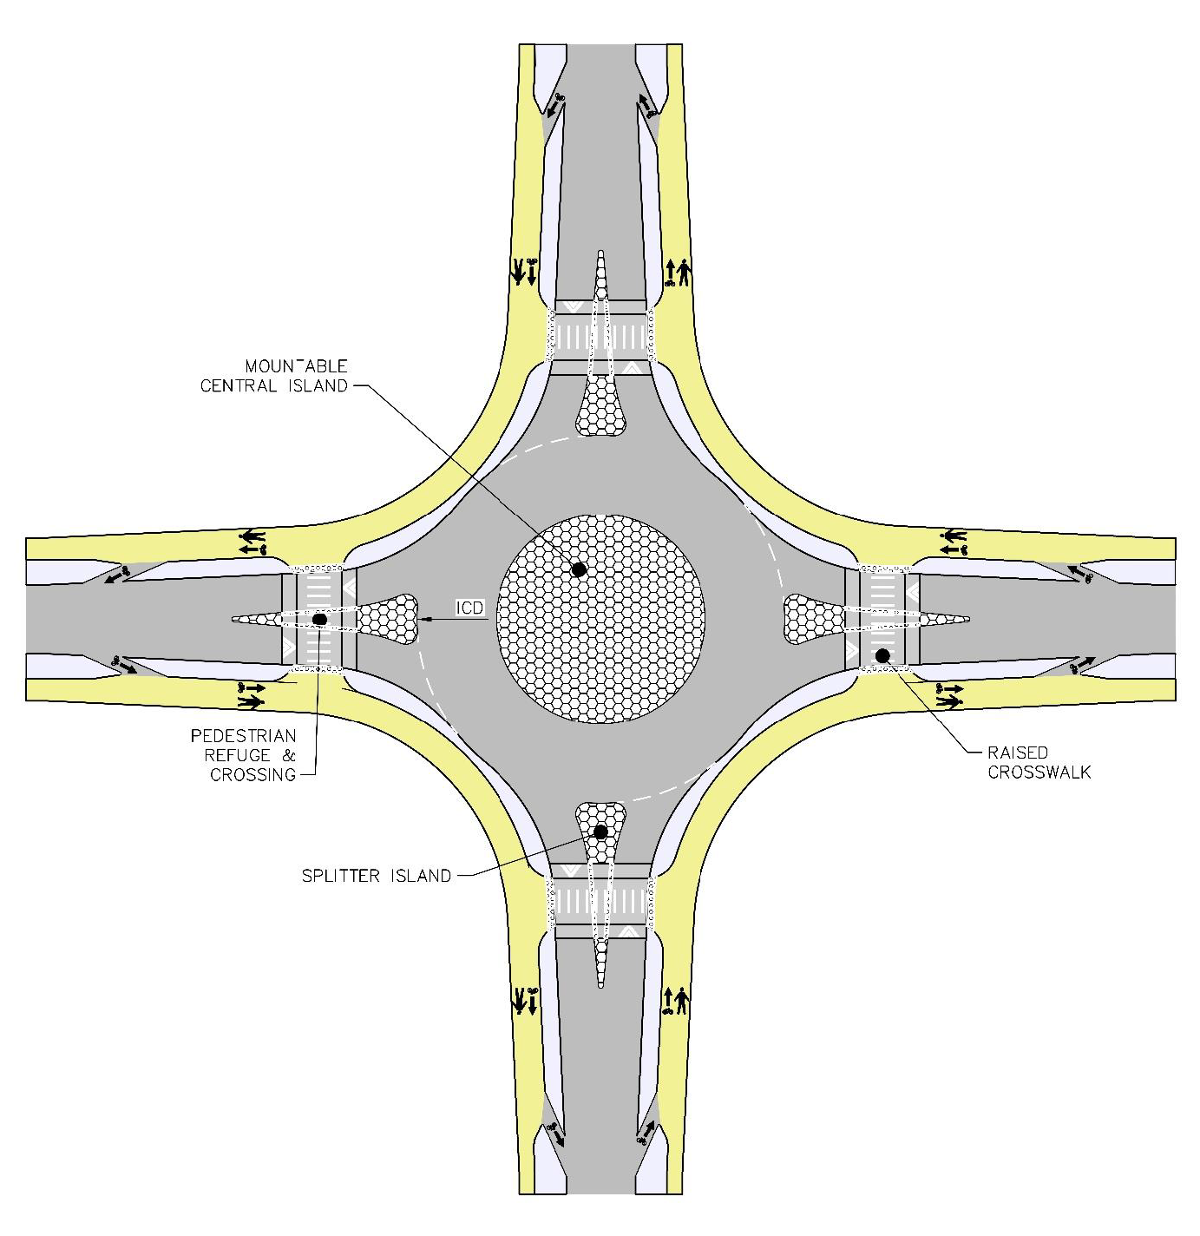
Figure 3-28 — Mini-Roundabout Typical Features
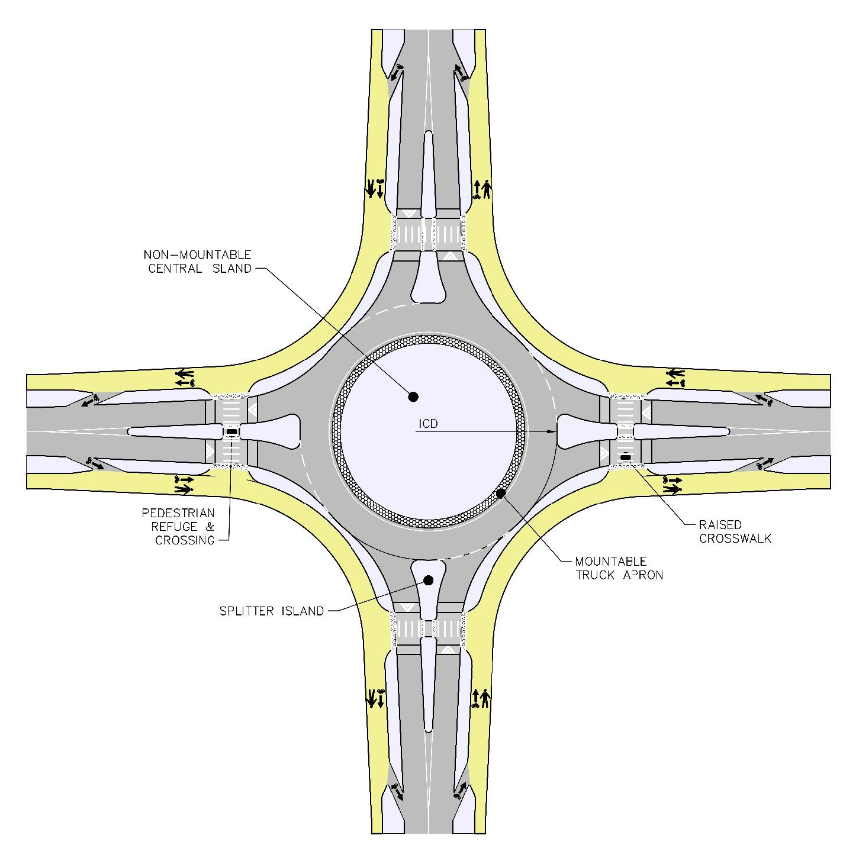
Figure 3-29 — Single Lane Roundabout Typical Features
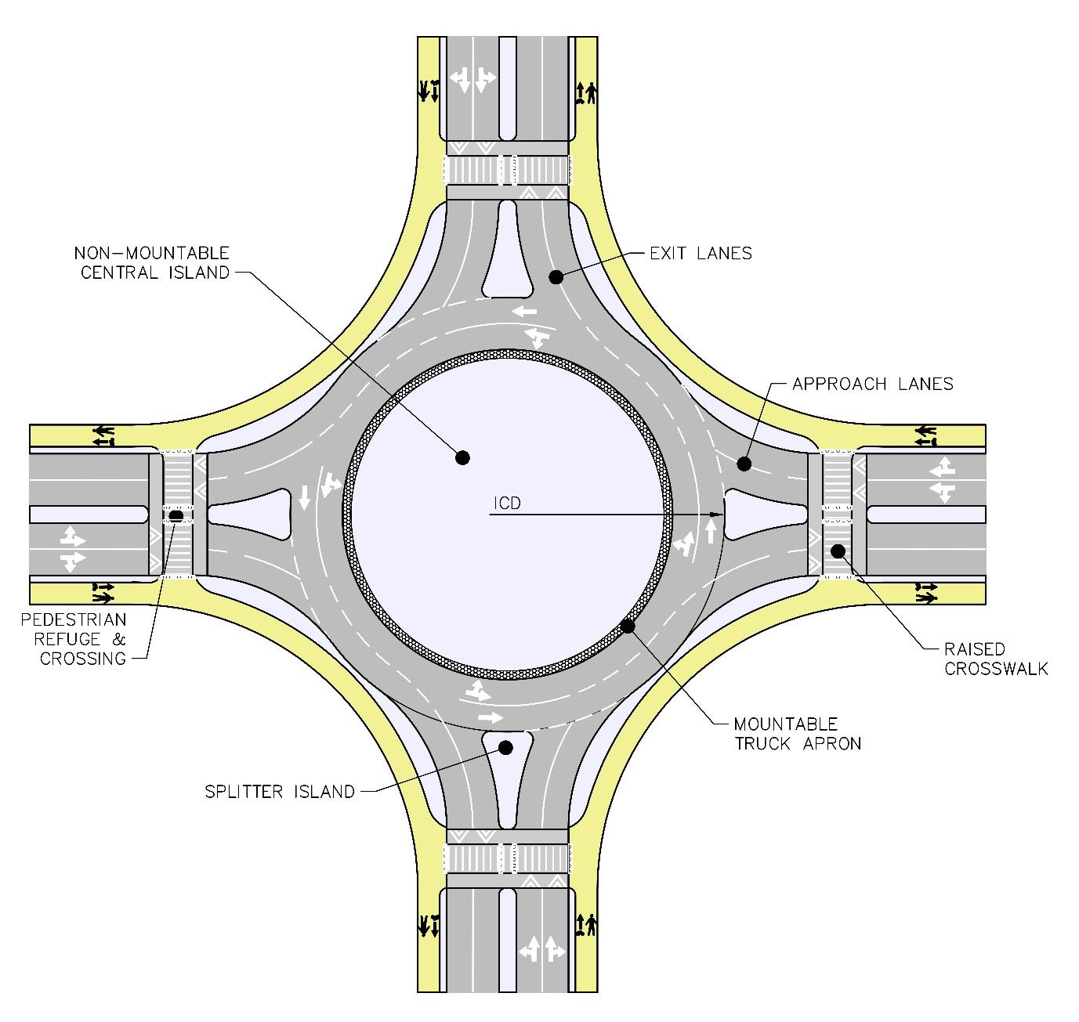
Figure 3-30 — Multi-Lane Roundabout Typical Features
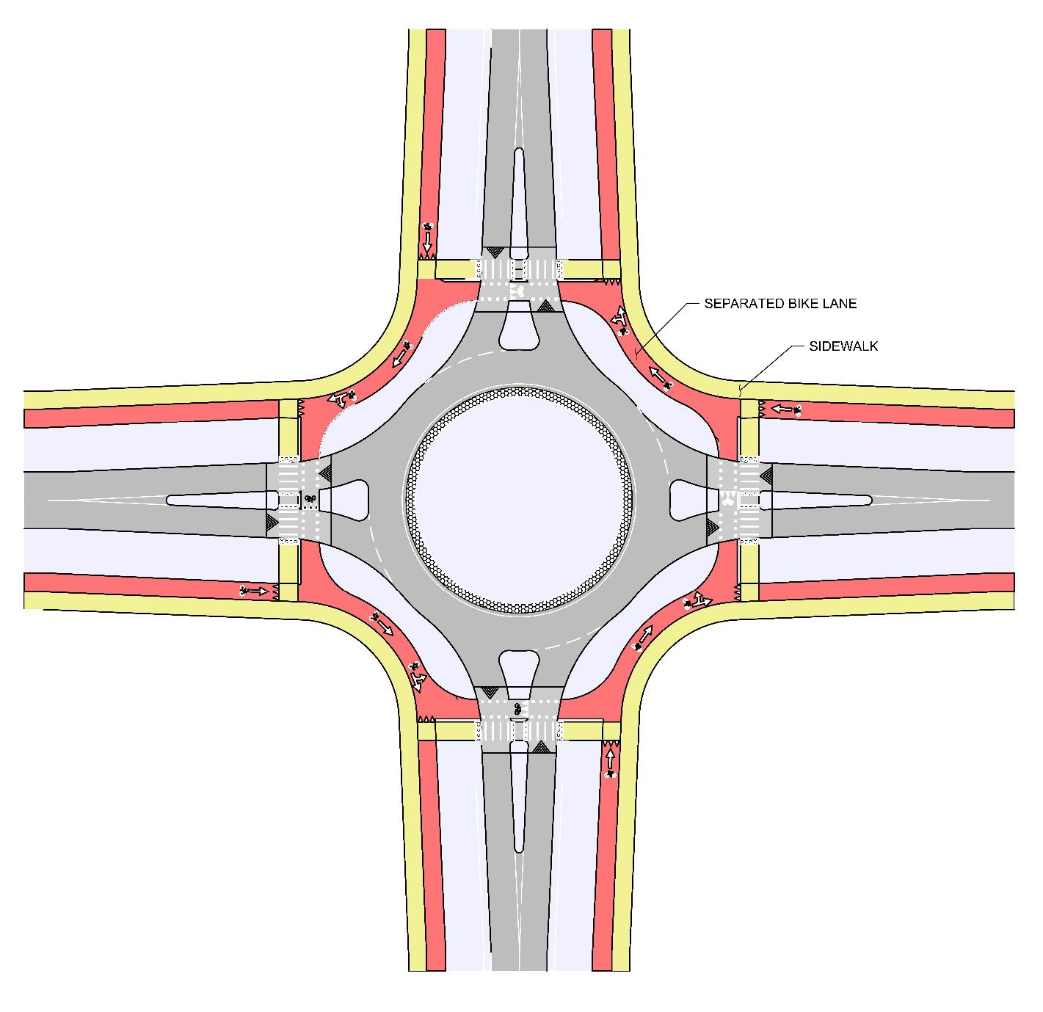
Figure 3-31 — Protected Bike Lane at Roundabout Typical Layout
A. Protected bike lanes shall continue through roundabouts as a separated facility with marked crossings and not enter the inscribed circle area of a roundabout where motorists circulate. An example of a protected bicycle facility at a roundabout is shown in Figure 3-31.

3.6.8 ADDITIONAL INTERSECTION TYPES
This section governs non-standard intersection geometries and control as determined by an Intersection Control Evaluation in Section 3.7.0 for new and reconstruction projects. Table 3-20 shows the various innovative intersection types and where to find design guidance on these intersection types (adapted from Florida ICE Manual, November 2017). These additional intersection types may be used in the ICE process and should be designed by a Professional Engineer licensed in the State of Texas with approval by the City Transportation Engineer or applicable Director, if deemed an appropriate solution through the ICE process.
Table 3-20 — Intersection Design Guidance Documents
Title | Description
FHWA-SA-14-069 Median U-Turn Intersection Informational Guide | PDF report providing guidance on median U-Turn (MUT) Intersections
http://safety.fhwa.dot.gov/intersection/alter_design/pdf/fhwasa14069_mut_infoguide.pdf
FHWA-HRT-09-055 Displaced Left-Turn Intersection | PDF report providing guidance on displaced left-turn intersections
http://www.fhwa.dot.gov/publications/research/safety/09055/09055.pdf
FHWA-SA-14-070 Restricted Crossing U-Turn Intersection Information Guide | PDF report providing guidance on restricted crossing U-turn (RCUT) intersections
http://www.fhwa.dot.gov/publications/research/safety/09055/09055.pdf
FHWA-HRT-07-032 Traffic Performance of Three Typical Designs of New Jersey Jughandle Intersections | PDF report providing guidance on New Jersey Jughandle intersections
http://www.fhwa.dot.gov/publications/research/safety/09055/09055.pdf
FHWA-SA-14-068 Displaced Left-Turn Intersection Informational Guide | PDF report providing guidance on displaced left-turn (DLT) intersections
https://safety.fhwa.dot.gov/intersection/alter_design/pdf/fhwasa14068_dlt_infoguide.pdf
FHWA-SA-09-016 Continuous Green T-Intersections | PDF report providing guidance on continuous green T-intersections
https://safety.fhwa.dot.gov/intersection/innovative/others/casestudies/fhwasa09016/fhwasa09016.pdf
FHWA-HRT-09-058 Quadrant Roadway Intersection | PDF report providing guidance on quadrant roadway intersections
http://www.fhwa.dot.gov/publications/research/safety/09058/09058.pdf

3.7.0 INTERSECTION CONTROL EVALUATION
Intersection Control Evaluation refers to a decision-making process and framework to provide a more balanced and holistic approach to the consideration and selection of access strategies and concepts during transportation planning, project identification and initiation processes that contemplate the addition, expansion or "full control" of intersections. Traditional methods rely heavily upon the TMUTCD and its stop control and signal warrants without consideration of other alternative approaches to intersection control.
Section 3.4.2.1 offers some standard intersection control types for Level 1 Streets within subdivisions that may be applicable as alternatives to traditional stop control.

3.8.0 SHARED STREETS
A shared street is designed to emphasize pedestrian mobility. This facility still permits vehicular traffic, however, it is designed to encourage pedestrian activity by slowing traffic speeds using pedestrian volume, street design, landscaping, lighting, and material selections to help influence driver behavior and contribute to the quality of place. A shared street is the flexible use of right-of-way, allowing vehicles, pedestrians, and bicycles to share the street equally. Shared streets should only be used on streets with low volumes where 10 mph or less can be attained through design and in areas where high multimodal activity exists and are limited to Level 0 and Level 1 Streets. Figure 3-32 illustrates the different areas of a shared street. Shared streets shall have retractable bollards at entry points to the street and shall maintain a minimum clear width of 20 ft. A shared street must be approved by the City Transportation Engineer or applicable Director. Separately, streets that include temporary or permanent closure to vehicles for exclusive non-vehicular traffic shall be approved by the City Transportation Engineer or applicable Director.
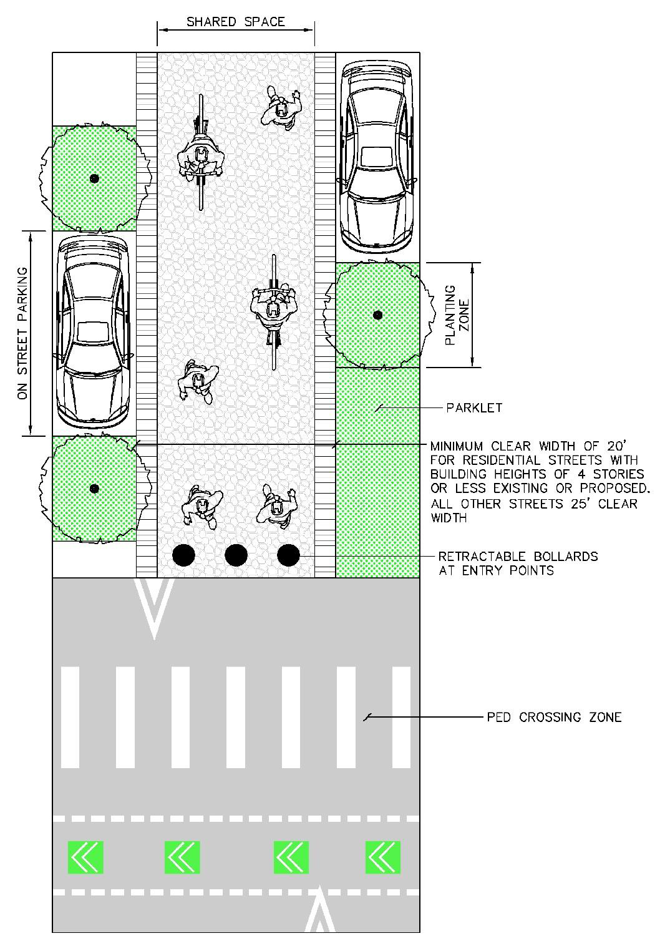
Figure 3-32 — Shared Street Typical Elements

